# Acknowledgment

First of all we would like to thanks the almighty God that gives as strength, patience and courage to do our project. We would also so much obligate to thank our advisor Mr.Thilleaswaran for his important advice and continuous suggestion. Secondly we would also thanks to our co-advisor Ato Getachew Tewachew for his valuable comments.

We would also like to express our heart full appreciation to all staff of computer science and it department teachers and our friend 4th year students for their help.

As the last we would thanks to Arba Minch tourist hotel and Ethiopian air line Arba minch branch employers for their help during data collection that are important for our system.

Table of Contents

Acknowledgment I

List of figure IV

List of table VI

Abbreviations VII

Abstract VII

Chapter One 1

1.1 Introduction 1

1.2 Background Information of the Organization (Background of the institution) 2

1.2.1 Vision of AMIT 2

1.2.2 Mission of AMIT 2

1.3 Back ground of the Project 2

1.4 Statement of the Problem 3

1.5 Team Composition 4

1.6 Objective of the Project 5

1.6.1 General Objective 5

1.6.2 Specific Objective 5

1.7 Feasibility Analysis 5

1.7.1 Operational Feasibility 5

1.7.2 Technical Feasibility 5

1.7.3 Economic Feasibility 6

1.7.4 Behavioral Feasibility 8

1.7.5 Schedule Feasibility 8

1.8 Scope of the Project 9

1.9 Significance of the Project 9

1.10 Target Beneficiaries of the System 9

1.11 Methodology for the Project 10

1.10.1 Data Source 10

1.10.2 Fact finding techniques 10

1.12 System Analyses and Design 10

1. 13 Development Tools 11

1.14 Testing Procedures (types of testing used) 11

1.15 Limitation of the Project 12

1.16 Risk and Contiguous 12

1.17 Risk, Assumption and Constraint 12

Chapter Two 13

2.1 Introduction to the Existing System 13

2.2 Players in the Existing System 13

2.3 Major Functions/Activities in the Existing System like Inputs, Processes & Outputs 13

2.4 Business Rules 14

2.5 Report Generated in the Existing System 15

2.7 Bottlenecks of the Existing System in terms of Performance, Input/output, Efficiency, Security and Controls. 16

2.7.1 Performance (response time) 17

2.7.2 Input (Inaccurate/redundant/flexible) and Output (Inaccurate) 17

2.7.3 Security and Controls 17

2.7.4 Efficiency 17

2.8 Practices to be preserved 18

2.9 Proposed Solution for the New System That Address Problems of the Existing System 18

2.10 Requirements of the Proposed System 18

2.10.1 Functional Requirements 18

2.10.2 Non-functional Requirement of the Existing System 19

Chapter Three 21

3.1 Introduction of System Analysis 21

3.2 System Requirement Specifications (SRS) 21

Use Case Identification 21

3.2.2 Use Case Documentation 23

3.2.3 Sequence Diagram 31

3.8.1 Activity Diagram 39

➢ Activity diagram for log in form 39

3.2.5 Analysis Level Class Diagram (conceptual modeling) 47

3.2.6 User Interface Prototyping 48

3.2.7 Supplementary Specifications 48

Chapter 4 49

4.1 Introduction System Design 49

4.2 Class Type Architecture 50

4.3 Class Modeling 52

4.4 State Chart Modeling 53

4.5 Collaboration Modeling 61

4.6 Component Modeling 66

4.7 Deployment Modeling 67

4.8 Persistence Modeling 68

4.9 User Interface Design 69

Chapter-5 73

Implementation and testing 73

5.1 Introduction 73

5.2Testing 73

5.3 Hardware and Software acquisitions 82

5.4 User manual preparation 83

5.5 Training 83

5.6 Installation 83

5.7 Start-up strategy 83

5.8 Coding 84

Chapter Six 90

Conclusions and Recommendations 90

6.1 Conclusions 90

6.2 Recommendations 90

References 91

Internet Site reference: 91

## List of figure

Figure 1 Ethiopian air line registration form 16

Figure 2 :use case diagrams 22

Figure 3 : sequence diagram for login 31

Figure 4 sequence diagram for registration 32

Figure 5 sequence diagram for browse information 33

Figure 6 sequence diagram for update information 34

Figure 7 sequence diagram for delete information 35

Figure 8 Sequence diagram for view profle 36

Figure 9 sequence diagram for generate report 37

Figure 10 sequence diagram select reservation 38

Figure 11 activity diagram for log in form 39

Figure 12 activity diagram for customer registration 40

Figure 13 activity diagram for update customer info 41

Figure 14 activity diagram for browse info 42

Figure 15 view profile 43

Figure 16 activity diagram for select reservation. 44

Figure 17 activity diagram for delete reservation 45

Figure 18 activity diagram for generate report 46

Figure 19 analysis level class diagram 47

Figure 20 user interface prototyping 48

Figure 21 Class type architecture 50

Figure 22 class modeling 52

Figure 23 state chart for login 53

Figure 24 state charts for registration 54

Figure 25 state chart for delete page 55

Figure 26 state chart for update page 56

Figure 27 Browse info 57

Figure 28 select reservation 58

Figure 29 Generate report 59

Figure 30 View profile 60

Figure 31 collaboration modeling for login 61

Figure 32 collaboration modeling for registration 61

Figure 33 Collaboration modeling for delete reservation 62

Figure 34 view profile page 63

Figure 35 Select reservation 63

Figure 36 Browse info 64

Figure 37 update info 64

Figure 38 generate report 65

Figure 39 component modeling 66

Figure 40 deployment modeling 67

Figure 41 persistence modeling 68

Figure 42 Admin login 69

Figure 43 Users hotel reservation page 70

Figure 44 users airline reservation page 71

Figure 45 Users car rental reservation page 72

## List of table

Table 1 team composation 4

Table 2:- Materials cost for existing system 6

Table 3 Materials cost for new system 6

Table 4Hardware costs 7

Table 5:- Software Cost 7

Table 6 *schedule feasibility* 8

Table 7:- development tools 11

Table 8 hotel registration form 15

Table 9 use case documentation for “login” 23

Table 10 use case documentation for “ registration” 24

Table 11 use case documentation for “update account” 25

Table 12 use case documentation for “Browse Reservation” 26

Table 13 use case documentation for “view profile” 27

Table 14 use case documentation for “delete reservation” 28

Table 15 use case documentation for “select reservation” 29

Table 16 Use case documentation for “generate report” 30

Table 17 class type architecture 51

Table 18 Testing 76

# 

## Abbreviations

* ARS Airline Reservation System
* HRS Hotel Reservation System
* CRS Car Rental System
* SRS System Requirement Specifications
* UNESCO United Nation Educational, Scientific and Cultural Organization
* MYSQL My structural Query Language
* OOA Object oriented Analysis
* OOD Object oriented Design
* PHP Hypertext Preprocessor
* UML Unified Modeling Language
* UI User Interface
* API Application Programming Interface.

# Abstract

The online reservation system has its database centrally located which is accessed through an Application Programming Interface (API).With the invent of online reservation system the traveler and the airline hotel and car rent got the freedom to book a seat anywhere at any time at their convenience.

The traveler can book a ticket at a click of a mouse saving the time and money for the traveler

Our project is online travel point system which is web application system that is designed for customers in order to replace the current manual way used by the three reservation system and to make reservation process easy to the users. The purpose of our project is to overcome problem faced by hotel reservation system, car rental and also in flight reservation system that uses manual system. Our project will have a user friendly graphical interface for the user and gives option to choose what type of service the customer wants. This Project is developed keeping in mind the security of the system.

# Chapter One

# 1.1 Introduction

Today communication plays a vital role for day to day activities of human kind so, Ethiopia is one of African country starting travel point service before some years ago

Online travel point is one of the largest system and nongovernmental organizations in Ethiopia which provides many services such as Airline Reservation System (ARS), Hotel Reservation System (HRS) and Car Rental System (CRS) for the customer, but currently there is no online travel point system. The current system working on the point of traveling is still doesn’t satisfy the customers need and doesn’t combine the three system. Now online travel point improves these drawbacks and implements the new feature of building world class infrastructure.

Currently traveling uses manual system and separate for generating payment from its customer by providing Airline Reservation, hotel reservation and car rental. Now we are doing to change this manual system to web based system and Air line reservation system used to this web based but still there are some problems.

Using this system guests will know their hotel and room, select car type and flights with whom they are assigned before coming to airport, hotel and tour and Travel Company.

This project also covers various features like online registration of the users, modifying the details of the website by the management staff or administrator of the website, by adding, deleting or modifying the customer details, flights or packages information. In general, this project would be designed to perform like any other ticket booking website available online.

# 1.2 Background Information of the Organization (Background of the institution)

Arber Minch University (AMU) is an academic and research based institution located in Arba Minch Ethiopia about 500 km south of Addis Ababa. The university is one of the well known higher learning institutions in Ethiopia providing quality services to its customers. Aspiring to be one of the leading higher learning institutions in Ethiopia, AMU developed both in physical infrastructures, human resources and in its service provisions to the community. The University nowadays is performing expansion and development plan which expects a combined effort of different sectors with in itself. Being as one of the vital gain to the development plans vehicle maintenance and deployment plays a greater role with respect to the technical support.

## 1.2.1 Vision of AMIT

Arba Minch University aspires to be a leading university in Ethiopia, a centre of excellence in the field of water resources in Africa and competitive in the world by 2020.

## 1.2.2 Mission of AMIT

Arba Minch University has a mission of promoting democratic thinking, offering high quality education and training, conducting demand driven and problem solving research and consultancy, and rendering community service in order to contribute to the development endeavors of the country.

# 1.3 Back ground of the Project

Ethiopia is one the fastest growing country in the world, so due to this reason number of guests comes to Ethiopia increase day to day. Ethiopian air line is the most successful and selected airline all over Africa and world (Wikipedia). In Ethiopia there are also many natural and cultural heritages that the guests come to visit because Ethiopia has many heritages recorded in UNESCO. Due to the development of country economy and number of guests come inside the country the number of hotels in the country also growing up fastly.`

Depending on the above description the status of the current system on traveling is not enough to handle these things since it is manual. So we develop an online system that will handle the current load and problem.

Most of the organization used computerized system in handling all their activities regarding with data processing in order to make the organization operation more efficient. All the manual activities are now can be done using computerized system.

This system is going to be used by three groups of users that are the customer, administrator and staff of Company. The purpose of this system is to overcome problem faced by company using the manual system. Online travel point is a web application system that is developed for customers and company in order to replace the current manual way used by the organization and to make reservation process easy to the users.

# 1.4 Statement of the Problem

The main problem of the existing system there is no any systems which combine those three reservation system in one system in Ethiopia.

The current system works manually, in which customer come physically for airline ticket booking, hotel reservation and car renting, the process is too long and time consuming*.* In the existing Airline Reservation for cancelling of flight, for different reason in such case the customers must come to the airport, which is also time taking and resource driven processing.

Efficiency of the current system with respect to giving services, to its customer is in sufficient and laborious. The present system is also costly because the guest must come to airport for ticket reservation, hotel for reserving and to rent car. Records and files of reservation information may be lost due to the manual system. No database to store information by using manual system and unstructured file handling.

# 

|  |  |  |  |  |
| --- | --- | --- | --- | --- |
| No | STUDENT NAME | ID NUMBER | E-mail | THE TASK |
| 1 | **MAHLET TAMMENE** | **RET/609/01** | [**Mahi3tam@yahoo.com**](mailto:Mahi3tam@yahoo.com) | **PROJECT**  **MANAGER** |
| 2 | **TADELE FERDA/**  **NIGATU DESTA/ MAHLET TAMMENE** | **RET/693/02** | [**Tadele.ferda@ymail.com**](mailto:Tadele.ferda@ymail.com) | **DESINGNER** |
| 3 | **TAMENE MULUGETA/ TADELE FERDA/ NIGATU DESTA** | **RET/694/02** | [**tamenem@ymail.com**](mailto:tamenem@ymail.com) | **PROG RAMMER** |
| 4 | **NETSANET SEBSIBE/ TAMENE MULUGETA** | **RET/1078/02** | [**Netsi.sebisbe@ymail.com**](mailto:Netsi.sebisbe@ymail.com) | **DATA COLLECTOR** |
| 5 | **NIGATU DESTA/ MAHLET TAMMENE/ NETSANET SEBISBE/** | **RET/807/02** | [**nigatudesta@rocketmail.com**](mailto:nigatudesta@rocketmail.com) | **STYSTEM**  **ANALYST** |

# 1.5 Team Composition

Table team composation

# 1.6 Objective of the Project

## 1.6.1 General Objective

The main objective of this project is to develop a web based system that provide a convenient way for a customer to reserve tickets, hotel and a car rental being in one system .

## 1.6.2 Specific Objective

The specific objective of the project is to provide at any time at anyplace service for the customer .To serve many people’s at a time and to increase the profit to obtain detail information from the booking record and car rental services.

* To provide direct access to customers through web application system.
* Design scalable data base
* Design a system or module to generate reports for administrator
* Integration of all records of passengers & employees
* Create user friendly environment
* To provide report generation and analysis such as the car rental report and Statistic from time to time.

# 1.7 Feasibility Analysis

## 1.7.1 Operational Feasibility

Our system is operationally feasible because the system is supported by the users and the management and it reduces the work load for managers and workers. The services of proposed system are flexible and expandable to the users. For this reason, the system is supported by the user. The system will not be degraded or declined. If some serious problems will be occurred, the system will be easily maintained by the team. Therefore, the system will be designed to be operationally feasible. That means, the system will operate in any kind of platforms without any failure.

## 1.7.2 Technical Feasibility

Our system will be technically feasible. The proposed platform has sufficient capacity for future needs. They can get easily the resources for our system which means they can acquire the resources such as hard ware, software and network resources easily. Customer easily develops, purchase, access or operate the system by using technical resources.

## 1.7.3 Economic Feasibility

Our systems review team will use the table, along with our cost estimates, to decide whether to follow the project beyond the preliminary investigation phase.

**Cost Benefit Analysis**

**A. Tangible Benefits**

Cost reduction for material

|  |  |  |  |
| --- | --- | --- | --- |
| Materials cost for existing system | | | |
| Item | Quantity per year | Unit price/Salary | Total Price/Salary per year |
| Papers | 300 packet | 80 Birr | 24,000 Birr |
| Pen | 40 packet | 40 | 1,600 Birr |
| Labor cost | 14 labor | 1000 | 168,000 Birr |
| Computer | 10 | 8000 | 80,000 Birr |
| Total Material cost |  |  | 273,600 Birr |

Table :- Materials cost for existing system

|  |  |  |  |
| --- | --- | --- | --- |
| Materials cost for new system | | | |
| Item | Quantity per year | Unit price/Salary | Total Price/Salary per year |
| Labor cost (recorder of student list) | 6 | 1000 | 6000 Birr |
| Paper | 3 packet | 80 | 240 Birr |
| Pen | 2 packet | 40 | 80 Birr |
| Computer | Already exist and 4 additional | 8000 | 32,000 Birr |
| Total material cost |  |  | 38,320 Birr |

Table Materials cost for new system

Difference b/n before and after deployment money required for payment

Cost Reduction for materials = 273,600 –38,320 birr = 235,280 birr

**B. Intangible Benefit**

* Increase information accuracy.
* Information processing efficiency
* Saving loss of documents

#### Cost of the Project

|  |  |  |  |
| --- | --- | --- | --- |
| **Tangible costs** Hardware costs | | | |
| Item | Quantity per year/cost | Unit price/Salary | Total Price/Salary per year |
| Labor cost (recorder of student list) | 5 | 1000 | 5000 Birr |
| CD_ROM | 6 | 5 | 30 Birr |
| Computer | Already exist |  |  |
| Total material cost |  |  | 5030 |

Table Hardware costs

|  |  |
| --- | --- |
| Software Cost | |
| Item | Price |
| mySQLserver2008 | 1000 Birr |
| Window 7 | 1400 Birr |
| Microsoft Office 2007 | 160 Birr |
| E_draw | 1000 Birr |
| Microsoft Visual studio. Net | 4000 Birr |
| Total | 7560 |

Table :- Software Cost

Total cost of the project =5030 birr for hardware cost + 7560 birr software cost, reduction for new system = 12590 birr

The general cost difference between existing system and new system is 235,280 birr- 12590 birr = 222690 birr

1. **Intangible costs**

* Development time
* Energy Consumption

**Cost Breakdown**

Beside tangible and intangible costs, we breakdown cost of system development into two: one time cost and recurrent cost.

* **One time cost**:Is a cost with project up and developments or system startup. This mean that it refers to those associated with project initiation and development cost and the startup of the system. The cost typing encompasses activities such as system development, new hardware & software purchase or system startup user training, and system or data conversion.
* **Recurrent cost*:*** Recurrent costs are those incurred for goods and services in the course of a budget year and which must be regularly replaced since we are developing this system as senior project, we may not gain any income.

## 1.7.4 Behavioral Feasibility

Our proposed system behaviorally feasible cannot cause any harm in the environments. The project would be beneficial because it satisfies the objectives of the customer. The system was developed user friendly and improves the working environment. Our system is free from any political and environments difficulty.

## 1.7.5 Schedule Feasibility

Schedule Feasibility shows us the plan of the team where to start and finish each phases of our project. Each phases of our project specified clearly when we finished and started even there are some phases not specified their time separately we decided to perform the on the specified time. We have planned to finish each phases regarding of the following schedule.

|  |  |  |  |  |  |  |  |
| --- | --- | --- | --- | --- | --- | --- | --- |
| Activities | Timeline schedule | | | | | | |
|  | | November25-Dec18 | Dec19-Jan1 | Jan2- April 03 | April 07 –June 10 | June 11-June 27 | June 28–  Jun 30 |
| Project Proposal | |  |  |  |  |  |  |
| Requirement  Analysis Phase | |  |  |  |  |  |  |
| Design | |  |  |  |  |  |  |
| Implementation | |  |  |  |  |  |  |
| System Testing | |  |  |  |  |  |  |
| Documentation &project submission | |  |  |  |  |  |  |

Table *schedule feasibility*

# 1.8 Scope of the Project

The proposed system will provide airline ticket reservation, hotel reservation and renting car online in one system.

Developing travel point system project is aimed to make a website for the airline ticket reservation, hotel reservation and renting cars for the tourists.

Some functionality of the system include:-

* Customer registration
* Giving information about attractive places in Ethiopia
* Decides the type of car and hotel
* Updates information
* Select room type
* Generates report
* Cancel reservation

# 1.9 Significance of the Project

Some of the Significances of the proposed system are:-

* Reduce the passenger waiting time to buy tickets and to get the service.
* Avoiding improper resource consumption
* Avoids improper communication.
* Avoiding data loss
* Tourists can book the ticket for airline, to reserve hotel and rent car over the Internet, at any time at anywhere.
* This online car rental solution is fully functional and flexible.
* It is very easy to use.
* This online travel point system helps in back office administration by streamlining and standardizing the procedures.

# 1.10 Target Beneficiaries of the System

There are different beneficiaries of this project

* Owner and workers uses the software to controls the system. Owners of those companies are benefited by the system because it reduces their employers, to give services for many guests at a time by their online systems and they give full time service for the guest.
* Guest also benefited by the system, they can get more information from the system to save the time, to get full information and to get service at any time.
* Workers those who use the system are benefited from the system can do their work easily, fastly and accurately.

# 1.11 Methodology for the Project

## 1.10.1 Data Source

* Relevant documents, forms ,procedures, policy documents
* [www.ethiopian](http://www.ethiopian) airline.com
* [www.adikatour](http://www.adikatour) &travel.com
* People concerned regarding the travel point

## 1.10.2 Fact finding techniques

*Interview***: -** To get the basic information about the background of the existing system interview will be conducted to tourist Hotels manager, Ethiopian Airline Arba minch branch.

*Document analysis***:** To get more information about the system we refer relevant documents and other reading materials about the reservation of hotel, car rental and airline.

*Practical observations*: To get additional information for the process of the existing system, we went to hotel and saw some activities which already mentioned above as problem. We did this because on some urgent issues they ignore providing appropriate information.

# 1.12 System Analyses and Design

In our project, we will apply the concept of object oriented system development methodology, because it manage and assemble objects that are implement in our system, and the composition of objects and interaction between objects on the system. This categorized in to two phases. These phases are object oriented analysis and object oriented design.

*Object Oriented Analysis (OOA):*During this phase we will look at the problem domain, and with the aim of producing a conceptual model of the information that exists in the area which will be analyzed. And this Model the functions of the system (use case modeling), identifying the business objects, organize the objects and also the relationship between them.

*Object Oriented Design (OOD):* During this phase Model object interactions and behaviors that support the use case scenario, and finally update object model to reflect the implementation environment. And also transforms the conceptual model produced in object-oriented analysis to take account of the constraints imposed to our system format, so that we will use this phase to refine the use case model to reflect the implementation environment.

**We will use this object oriented methodology for the following purposes:**

* **Simplicity**
* **Maintainable**
* **Faster Development**
* **Increased Quality**

# 1. 13 Development Tools

In this project the following system development tools will be used:-\\

|  |  |
| --- | --- |
| Activities | Tools/Programs |
| Client side coding | HTML |
| Client side scripting | Java script |
| Platform | Ms-windows |
| Database server/back end | Mysql, Xamp |
| Web server | Apache |
| Server-side scripting | Php |
| Editors | Macromedia Dreamweaver, E-draw |
| Documentation | MS Word |

Table :- development tools

# 1.14 Testing Procedures (types of testing used)

Before directly deploying this system the team will perform different types of testing procedures for its functionality and meeting customers need

**Unit testing**: - First we will tests each unit at each system. So, if a problem is encountered it willimmediately maintain at which the problem is occurred.

**Black box testing**: -Our project can be viewed solely in terms of its input, output and transfer characteristics without any knowledge of its internal workings

**Integration Testing: -** After we test each unit of the proposed system we will perform an integration test to check whether the system meets all the functional requirements. When a number of components are complete; it will test to ensure that they integrate well with each other, the operating system, and other components.

**Quality Assurance (system) testing***:-*After all of the above testing are checked we will test our system by other peoples and we will conduct some comments how they get our system.

# 1.15 Limitation of the Project

Limitation of the proposed system is:-

* Shortage of time to finish the project.
* Lack of experience.

# 1.16 Risk and Contiguous

There may be risks during the development of the system, some actions may occur when we are doing our project (Those actions may be damaged our system that is why we say risk). There may be losing data from our machine (computer) when there is power failure operating system scratched. It responding on appropriate schedule that leads our system not accepted by the users.

# 1.17 Risk, Assumption and Constraint

Technical Risks: These risks may result from excessive constraints, lack of experience, poorly defined parameters, or dependencies on organizations outside the direct control of the project team. In order to mitigate or control this risk the team will perform periodic checks on the work that have been done, and by using continuous advice provided from the project advisers.

Requirement changes: since this risk leads to system poor communication resulting in misunderstandings and quality problems, the team altered participatory type of data modeling to overcome such risks.

In addition there are other risks like power frailer, virus attack, when one group members fail to continue with us

# Chapter Two

# 2.1 Introduction to the Existing System

The current system gives services to the tourists in separately. The customers book airline ticket, reserve hotel and rent a car in different places and different ways with different systems.

The current system used to gather the requirements in our proposed system. The purpose of studying the current system is to identify the existing entities. It also to gather requirements and identify problem in the current system.

In the existing system for car rental is fully manual that means the guest must come to the company physically, select the car type and pay for it.

The current system for hotel reservation is also manual to do all activities and Air line reservation system is web based but it has no combination with car rental and hotel reservation systems.

# 2.2 Players in the Existing System

Some of players in the existing system are:-

* Customer
* Managers
* Employers
* Receptionist (Ticket sellers)
* Airline scheduler

# 2.3 Major Functions/Activities in the Existing System like Inputs, Processes & Outputs

**The Major Activities Done in Existing System are listed below**

Major activities for airline reservation system are:-

**Input:** - inputs for airline reservation system are name, last name and age of the passenger, the start place, the place where the passenger wants to go, time and date of travel, the class of the plane he wants to reserve and money.

**Process:** - the passenger fills information in the prepared form in the airport. Also fill

The necessary information to reserve hotel the same to rent car by appearing physically.

**Output:** - as an output the passenger receives the ticket.

Major activities for hotel reservation system are:-

**Input:** - inputs for hotel reservation system are name, last name and id of the customer, for how many days he wants to stay, kind of room he want to reserve (the class which can have one bed or two bed) and payment of that room.

**Process:** - the customer fills the information.

**Output:** - as an output the customer receives the key of the room he/she book.

Major activities for car rental system are:-

**Input:** - inputs for car rental system are name, last name and id of the customer, for how many days he wants to rent , type of car he want to rent and payment for that car.

**Process:** - the customer fills the information.

**Output:** - as an output the customer receives the key of the car he rent.

# 2.4 Business Rules

Existing system has its own business rule and the proposed system take this rules as they are some of them are:-

**For Airline Reservation**

* If Customers have child less than two years old child that go with them. They pay 10% of the total price only for his child and the child can’t get a sit.
* Customer pays 70% of the total price for 2- 12 years old children’s.
* Customers get discount if they buy ticket when they go and back to their destination, but this discount vary depend on the time, that customers will back and this rule work for international flight only.
* Ticket price vary based on time.
* There is also discount for spatial customers.
* Ticket value varies according to the class the customer chooses.

**For Hotel Reservation**

* Customer get discount when they book with his girl friend or wife.
* Customer must have an ID (identification card).
* The price of the room depends on their quality.

**For Car Renting**

* Customer must have license of driving.
* Customer must choice type of car.
* If any problem happens to the car, the customer must tell to renting company.

# 2.5 Report Generated in the Existing System

Current system of car rental and hotel booking services are manual. From this system we take some forms as they are. For airline system they have computerized system we can also some forms from this system and we combine them into one.

2.6 Forms and other Documents of the Existing Systems

**አርባ ምንጭ ቱሪስት ሆቴል**

**Arba Minch Tourist Hotel**

**Tel 046 881 21 71**

***እንግዳ መመዝገብያ ቅጽ***

***Guest Registration Book***

|  |  |  |  |  |  |  |  |  |  |  |
| --- | --- | --- | --- | --- | --- | --- | --- | --- | --- | --- |
| ስም  Gust name | የገባበት ቀን  Date in | ዜግነት  Nationality | ስራ  Profession | መ.ቁጥር  Card NO | ስልክ  Tel | የመጣበት አገር  Coming From | የሚቆይበት ጊዜ  Purpose of coming | የሚሔድበት ጊዜ  Departure  Date | ያረፈበት ክ/ቁ  Room No | ፊርማ  Signature |
|  |  |  |  |  |  |  |  |  |  |  |
|  |  |  |  |  |  |  |  |  |  |  |
|  |  |  |  |  |  |  |  |  |  |  |
|  |  |  |  |  |  |  |  |  |  |  |
|  |  |  |  |  |  |  |  |  |  |  |
|  |  |  |  |  |  |  |  |  |  |  |
|  |  |  |  |  |  |  |  |  |  |  |
|  |  |  |  |  |  |  |  |  |  |  |
|  |  |  |  |  |  |  |  |  |  |  |
|  |  |  |  |  |  |  |  |  |  |  |

Table hotel registration form

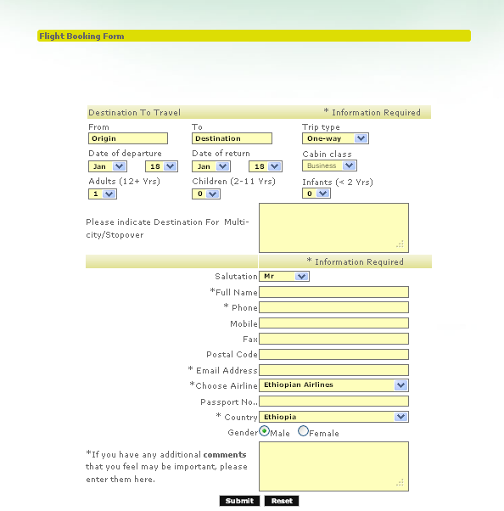

Figure Ethiopian air line registration form

# 2.7 Bottlenecks of the Existing System in terms of Performance, Input/output, Efficiency, Security and Controls.

There are a lot of problems in the existing system as compared to the proposed system. These problems can be seen from the following perspectives like performance, information, economic, control, efficiency and services given by the existing system to the users, by using the PIECES framework as follow:-

## 2.7.1 Performance (response time)

Since the existing system is manual, it takes long response time. For example when one guest need to reserve hotel, and book airline ticket and to rent car he must appear physically in the places and it takes long time. The acceptable response time for a particular task is large. But in the proposed system concurrency problems can be solved by the new system at a time.

## 2.7.2 Input (Inaccurate/redundant/flexible) and Output (Inaccurate)

**Input**

* List of the guest does not contain their full information on the papers.
* Receive the incorrect/redundant guest list.
* To fill incorrect name, user id, room and the specific time.

**Out Inaccurate**

* One guest is assigned more than one place. Due to this reason there is shortage of place.
* Without checking the guest materials, clearance is given for the guest.
* Not show the starting and ending time for the guest

## 2.7.3 Security and Controls

In the existing system security and control is somewhat worried about. It is difficult to control the system because there is no privilege in data accessing. Here the necessary reports may not generate at exact time so it may occur security violence. The system shouldn’t provide sufficient protection for access and manipulation of the records associated with the system. So it is not easily protected and used properly the resource.

## 2.7.4 Efficiency

In manual operation, most of the activities are prone to wastage of resources like papers, man power, time etc. to produce the corresponding outputs. This makes the current system inefficient while utilizing resources. There should be a mechanism that reduce wastage of resources and that make the system to be efficient. As a result the new system will reduce wastage of resources and make it efficient.

The existing system has less efficiency than the proposed system. The existing system has concurrency control problems i.e. more number of users. Data management facilities are limited and the reporting schemes are not according to the specific needs of the users.

# 2.8 Practices to be preserved

The system displays all the flight’s details such as flight no, name, price and duration of journey etc.

* The system allows the airline passenger to know flights that are available between the two travel cities, namely the “Departure city” and “Arrival city”.
* The system takes the detail information about the gust.
* All car rental companies require a valid driver’s license form.
* Checks the availability of the services.

# 2.9 Proposed Solution for the New System That Address Problems of the Existing System

* The important thing is to make works easy
* It is computerized online ticket issue process
* Computerization of the system must fulfill the requirement of giving effective services in terms of speed, accuracy, response time, efficiency, etc.
* The proposed system stores all the information about reservation on the database other than paper file.
* The new system leads the customer to get the services by using one system through links.

# 2.10 Requirements of the Proposed System

## 2.10.1 Functional Requirements

Once the guest makes a reservation, he/she must be provided with private codes (user name &password.). If the code provided by the customer does not match, then would notify the person by displaying error messages. The system will allow the customer to modify his/her reservation provided correct code has been entered by him. The code will generate during reservation and only for the person. If no reservations are made, then a message is displayed that no bookings have been made. The system will allow the administrator to view all the details of the customer who have made reservations

**Performance Requirements**

* The system capable to increase total throughput speed under an increased load when resources are added
* Enable the users to create, modify, or even to delete his/her account if it is necessary
* The system can generate information and forms for user to access Friendly

**Input Related Requirements***:* There will be accurate and flexible input mechanisms.

The input form must include name, date, time, code, customer login detail and others

Collecting the information of the guest who is going to reserve hotel, book airline ticket and rent car. The administrator must enter the password so that access is given only to him to view the details of the entire guest.

**Process Requirements *፡***There will be efficient storage and easy traceability/giving an outline/ and guest must have his/her own account to cancel or modify his/her reservation

During reservation the guest should fill full the appropriate information in the specified

Places and a code will generate used for access securely. If there is no code any one can delete others persons reservations. Even for modifying your reservations the code is useful.

**Output Related Requirements*:*** Since the input is effective the output is also effective. There will be accurate display of guest reports in accordance with the query process accessibility is possible for whom who has an account and no one can view information unless matched successfully. If the match is successful, account of the tourist will displayed and can view and information. If the match is unsuccessful, inappropriate message displayed. A new code will be generated for the guest.

**Storage Related Requirements፡**

There will be efficient storage and the entire entire processed system can stored in the data base.

## 2.10.2 Non-functional Requirement of the Existing System

**Performance** ፡-

Performance requirements define acceptable response times for system functionality.

Response time of the Airline Reservation System should be less than 2 second most of the time. Response time refers to the waiting time while the system accesses, queries and retrieves the information from the databases

* The load time for guest interface shall take no longer than two seconds.
* The log in information shall be verified within five seconds.
* Response time of the system will not take long almost in 10 seconds
* The system should support many user to reserve at a time
* The system is work 24 hours per day seven days in a week which means the system is always work.
* The tourist’s information must save as class in the data base in few hours after the end of registration.

**User Interface:**

The window format and the forms prepared for the information are easy to the guest they can easily understand.

The system shall be design according to standards and the system shall replace existing system.

ARS (Air line reservation system) shall provide an easy-to-use graphical interface similar to other existing reservation system so that the user does not have to learn a new style of interaction. The best thing in the input design is to achieve all the objectives mentioned in the simplest manner possible and creating reports for displaying and storing information

**Security and Access Permissions:**

Only system administer has the right to change system parameters, such as time change. The system should be secure and must use encryption to protect the databases. Users need to be authenticated before having access to any personal data.

**Backup and Recovery:**

* If the connection between the user and the system is loss the system will automatically save the filled information and the remaining can enable by the administrator by contacting the guest using phone.
* Both databases used for guest account and reservations are production databases. The main operation used for the backup and recovery is Oracle's built-in cold backup.
* ARS shall be able to recover from hardware failures, power failures and other natural disaster and rollback the databases to their most recent valid state

**Resource**

The main non functional resource is: - Server in back end and operating system in the application of the system. In the other case on of the most and available resource is internet access.

# Chapter Three

# 3.1 Introduction of System Analysis

As mentioned in the previous chapter in this project, the team used an object oriented System development methodology which incorporates two principal phases. In this chapter, what the team will do is the object oriented analysis (OOA) in this phase we can identify the relationship between objects and the interaction between each object. During Object Oriented Analysis the following major activities are performed.

# 3.2 System Requirement Specifications (SRS)

**Actor Identification**

Customer: - someone books online for airline reservation and hotel reservation and car rental.

Administrator: - a special user of the system who can setup access right for other users.

*Employee*:-is a person who checks whether the customer reserve ticket or not.

*Manager: -* person who generate reports and manage employers.

## Use Case Identification

Registration:-if the customer is a new user, he can request to register with the system. The

System displays a registration page. The customer is also required to enter their name and address and other information's.

Updateinformation: - the administrator can request to update their customer information.

Viewinformation: - the customer requests to view the flights, reservations, and information

about the company. The system will display the airline reservation, hotel reservation and about

the car rental.

Fillinformation:-the customer enter the necessary information

Specified place in the country.

Delete reservation:-the system administrator removes the reservation from the database after

Used.

**3.2.1 Use case diagrams****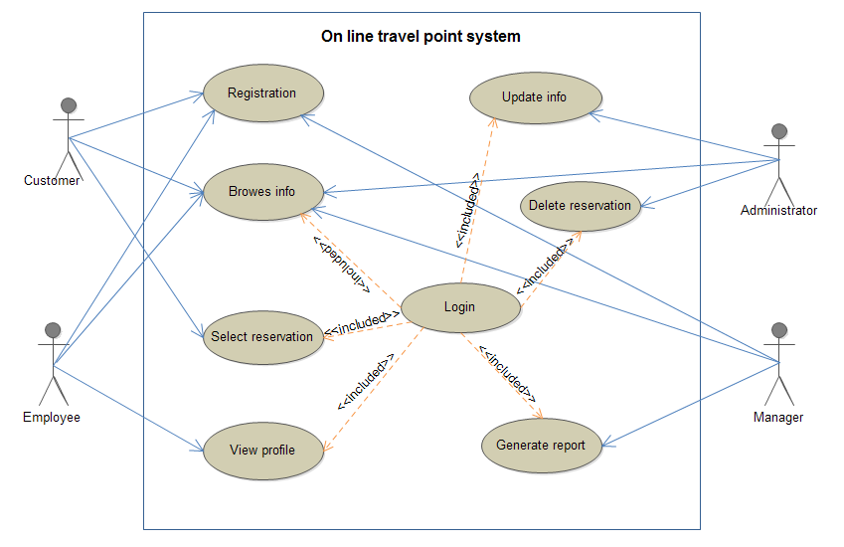**

Figure 2 :use case diagrams

## Use Case Documentation

#### Security Login

The following consecutive tables show the use case documentation for each of the use cases that has identified in the above use case diagram.

|  |  |  |
| --- | --- | --- |
| Actors | Administrator ,Employee, Manager | |
| Use case name | Login | |
| Use case Id | 01 | |
| Description | Login to the system | |
| Pre-condition | The user has been registered. | |
| Post condition | The user has been authorized. | |
| Basic course of action | Actor Action | System Response |
| Step1: The user wants to login  Step3: The user enter username and password | Step2: The System display user log in form.  Step4:The system validates whether the username and password submitted is correct (already in the data base)  Step5: The system display the user account page  Step6: The use case ends |
| Alternative curse of action | 01. The user enter wrong username and password  Step 4.1 The system indicates the user information invalid  Step 4.2 The use case continues Step 3 of the basic course of action | |

Table use case documentation for “login”

#### Registration

|  |  |  |
| --- | --- | --- |
| Actors | Customer,Manager,Employee | |
| Use case ID | 02 | |
| Use case name | customer Registration | |
| Description | This use case allows passengers to register in to the system | |
| Pre-condition | The passenger wants to reserve airline, hotel and car rental | |
| Post condition | The passenger registers into the system | |
| Basic course of action | Actor Action | System Response |
| Step1: The User wants to register in to the system.  Step3: The user enters the necessary information in the customer registration page. | Step2: The system Displays customer Registration page  Step4: The system validates whether the information submitted is correct or not.  Step5: The system register and displays customer Registration Confirmation page and leads to his or her account  Step6: The use case ends |
| Alternative curse of action | 02. The input information invalid  Step 4.1 The system indicates the user information invalid  Step 4.2 The use case continues Step 3 of the basic course of action | |

Table use case documentation for “ registration”

* **Update Information**

|  |  |  |
| --- | --- | --- |
| Actor | Administrator | |
| Use case ID | 03 | |
| Use case name | Update information | |
| Description | This use case allows To update user information | |
| Pre-condition | The administrator wants update user information | |
| Post condition | The administrator have information that will be updated | |
| Basic course of action | Actor Action | System Response |
| Step1: the administrator can request to update the user information and other information in the database.    Step3: The administrator enters the necessary new information. | Step2: The system Displays user information update page  Step4: The system validates whether the information submitted is correct  Step5: The system displays Confirmation page and save the updated information.  Step6: The use case ends |
| Alternative curse of action | 03. The input information invalid  Step 4.1 The system indicates the user information invalid  Step 4.2 The use case continues Step 3 of the basic course of action | |

Table use case documentation for “update account”

**Browse Information**

|  |  |  |
| --- | --- | --- |
| Actors | Administrator, Employee, Manager, Customer | |
| Use case ID | 04 | |
| Use case name | Browse information | |
| Description | The user requests to view reservations of flights, hotel and car rent. | |
| Pre-condition | The user has been logged in. | |
| Post condition | The user has been viewed all reservations. | |
| Basic course of action | Actor Action | System Response |
| Step1: The user wants to view reservation.  Step3: The user enters select the "reservation" button. | Step2: The System display view reservation page.  Step4 : The system process selection  Step5: The system display the different reservations select of the reservations based on the need of the customer.  Step6: The use case ends |
| Alternative curse of action | 04. The user selection is incorrect  Step 4.1 The system indicates the user information invalid  Step 4.2 The use case continues Step 3 of the basic course of action | |

Table use case documentation for “Browse Reservation”

* **View Profile**

|  |  |  |
| --- | --- | --- |
| Actors | Employee | |
| Use case ID | 05 | |
| Use case name | Browse information | |
| Description | The Employee requests to view profiles of customers which can reserve flights, hotel and car rent. | |
| Pre-condition | The Employee has been logged in. | |
| Post condition | The Employee has been viewed all reservations. | |
| Basic course of action | Actor Action | System Response |
| Step1: Employee wants to view profile.  Step3: Employee select from the three reservations (flights, hotel and car rent.). | Step2: The System display view profile page.  Step4 : The system process selection  Step5: The system displays customer’s profile which can book for that reservation  Step6: The use case ends |
| Alternative curse of action | 04. The user selection is incorrect  Step 4.1 The system indicates the customer’s information invalid  Step 4.2 The use case continues Step 3 of the basic course of action | |

Table use case documentation for “view profile”

* **Delete Reservation**

|  |  |  |
| --- | --- | --- |
| Actors | Administrator | |
| Use case Id | 06 | |
| Use case name | Delete Reservation | |
| Description | This use case describe the canceling reservation process | |
| Pre-condition | In case the customer doesn’t want to ticket on that day | |
| Post condition | The selected reservation has been cancelled and updating the database  information | |
| Basic course of action | Actor Action | System Response |
| Step1: The administrator wants to cancel the reservation  Step3: Enters the reservation number  Step5: Selects the "Process Cancellation" option. | Step2:The system Displays Cancel Reservation page  Step4: The system validates whether the information submitted is correct  Step6: The message "Reservation Successfully Cancelled" is also displayed.  Step7:The use case ends |
| Alternative curse of action | 06. The input reservation number is invalid  Step 4.1 The system indicates the user information invalid  Step 4.2 The use case continues Step 3 of the basic course of action | |

Table use case documentation for “delete reservation”

* **Select Reservation**

|  |  |  |
| --- | --- | --- |
| Actor | Customer | |
| Use case Id | 07 | |
| Use case name | Select reservation | |
| Description | This use case describes selection of reservation customer wants to get from the three type of reservations. | |
| Pre-condition | Customer must be register. | |
| Post condition | Selecting reservation. | |
| Basic course of action | Actor Action | System Response |
| Step1: The customer wants to select the reservation.  Step3: click on the Reservation you want. | Step2: The system Displays a page to select Reservation.  Step4: The system Displays Reservation page for the selected type of reservation.  Step5: the use case ends. |
| Alternative curse of action | 07. The selection is invalid  Step 4.1 The system display the selection value is incorrect  Step 4.2 Go to step 2 is basic course of action | |

Table use case documentation for “select reservation”

* **Generate Report**

|  |  |  |
| --- | --- | --- |
| Actor | Manager | |
| Use case Id | 08 | |
| Use case name | Generate report | |
| Description | This use case gives information about sold tickets | |
| Pre-condition | In case the manager want to generate report on that day  Or for the week | |
| Post condition | The necessary report generated and saved to the database. | |
| Basic course of action | Actor Action | System Response |
| Step1: The manager wants to generate report  Step3:Manager enters the generated report  Step5: Selects the "Process of report generation" option. | Step2:The system Displays generate report page  Step4: The system checks whether the report is correct or not  Step6: The message "report successfully generated" is also displayed.  Step7:The use case ends |
| Alternative curse of action | 08. The generated report is invalid  Step 4.1 The system indicates the user information invalid  Step 4.2 The use case continues Step 3 of the basic course of action | |

Table Use case documentation for “generate report”

## 3.2.3 Sequence Diagram

* **Sequence diagram for login**

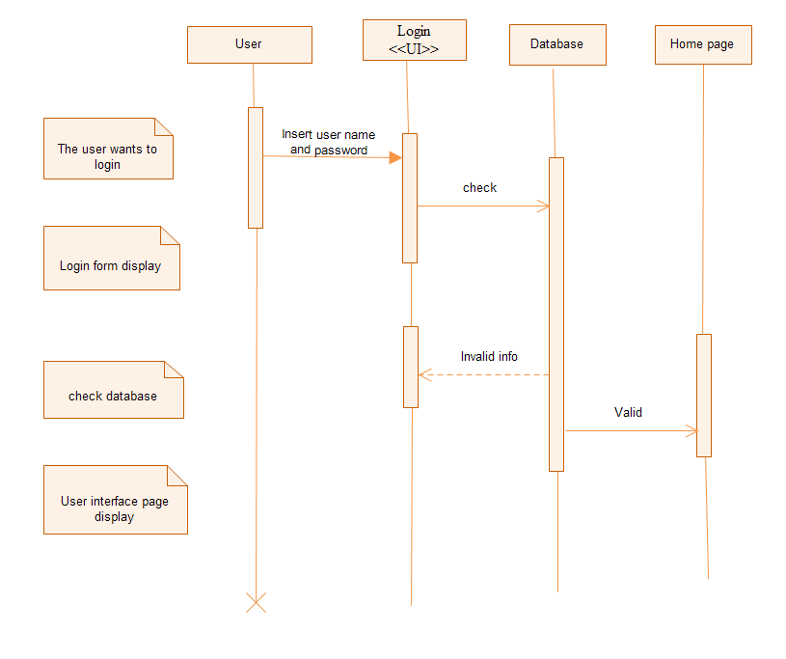

Figure : sequence diagram for login

* **Sequence diagram for registration**

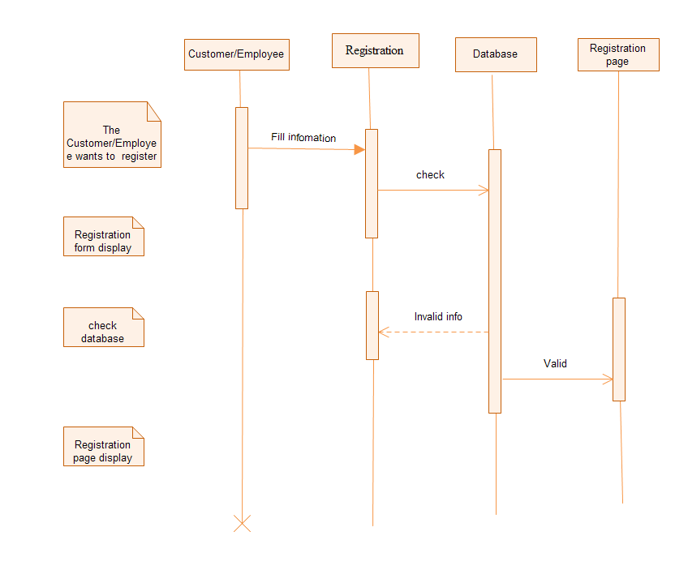

Figure sequence diagram for registration

* **Sequence diagram for browse information**

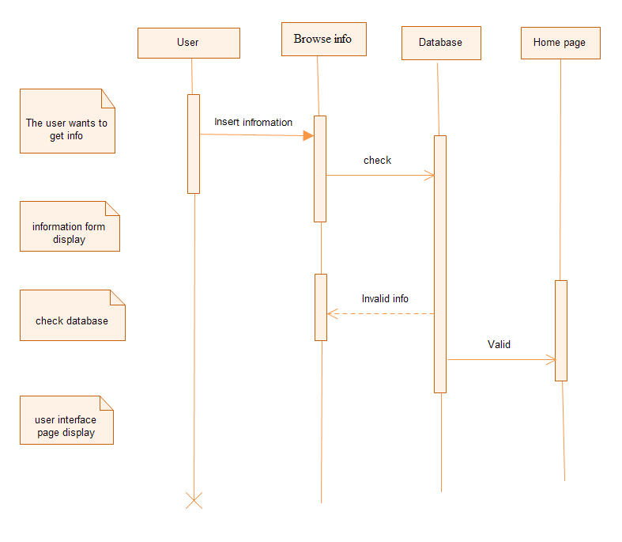

Figure sequence diagram for browse information

* **Sequence diagram for update information**

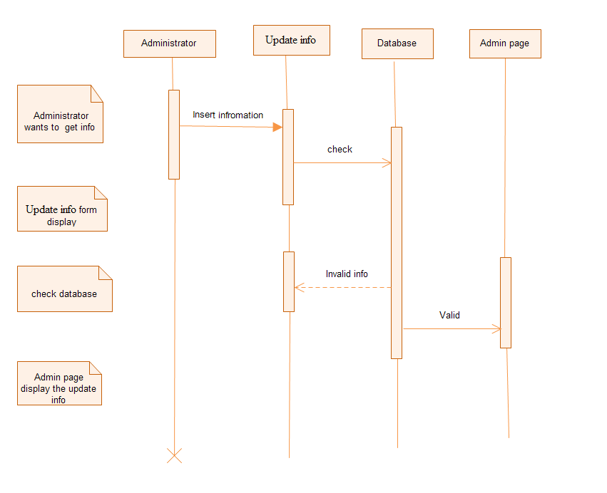

Figure sequence diagram for update information

* **Sequence diagram for delete information**

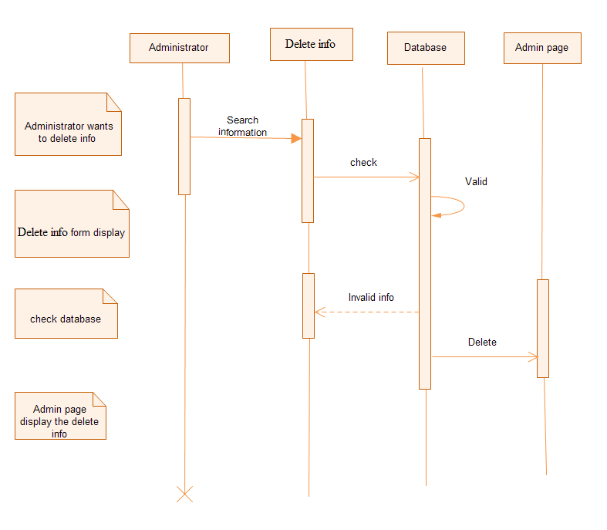

Figure sequence diagram for delete information

* **Sequence diagram for view profile**

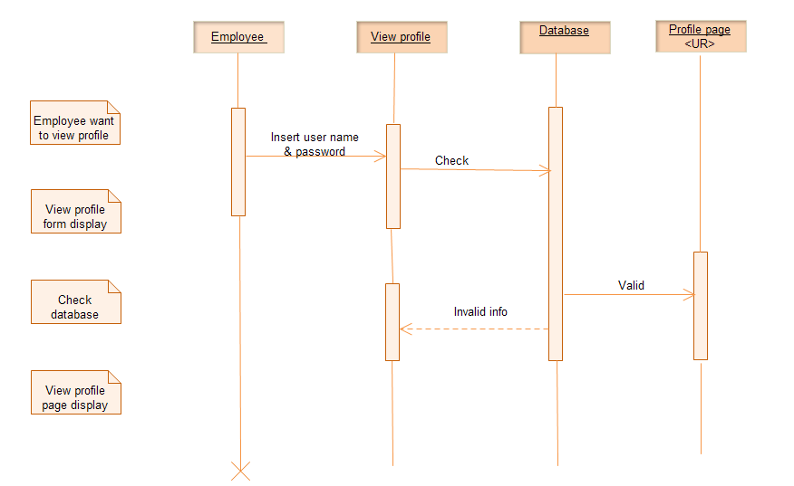

Figure Sequence diagram for view profle

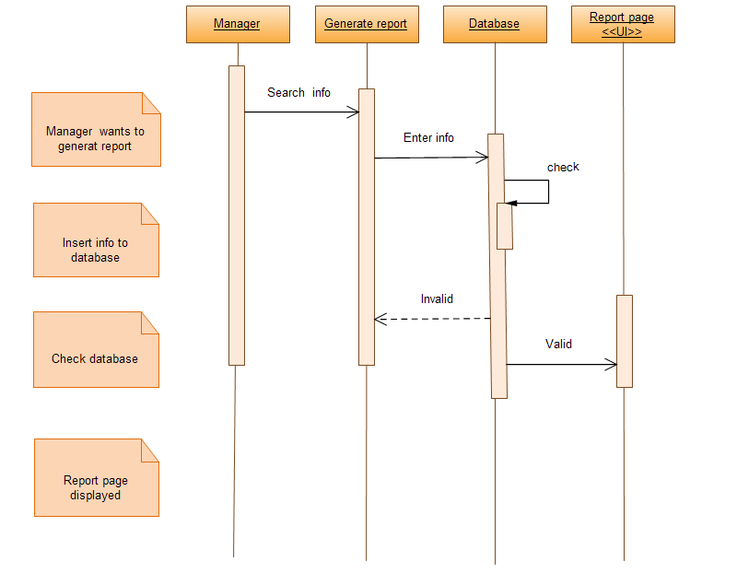

Figure sequence diagram for generate report

* **Sequence diagram Select reservation**

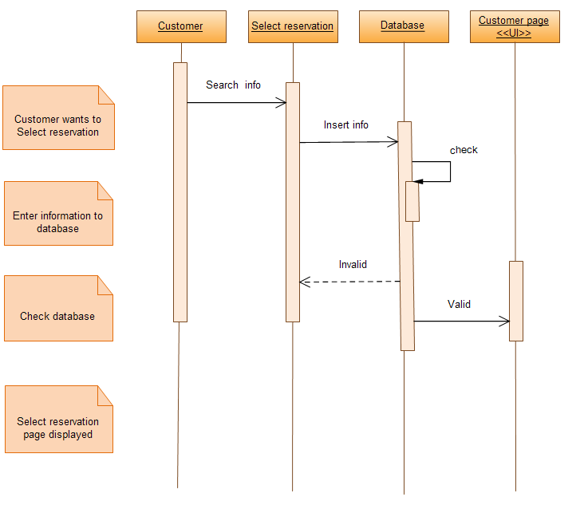

Figure sequence diagram select reservation

## Activity Diagram

## Activity diagram for log in form

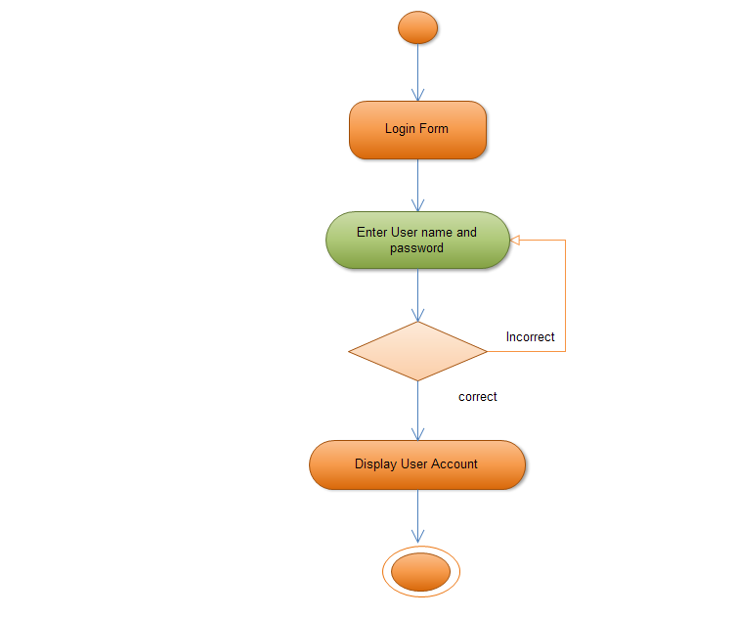

Figure 11 activity diagram for log in form

* **Activity diagram for customer registration**

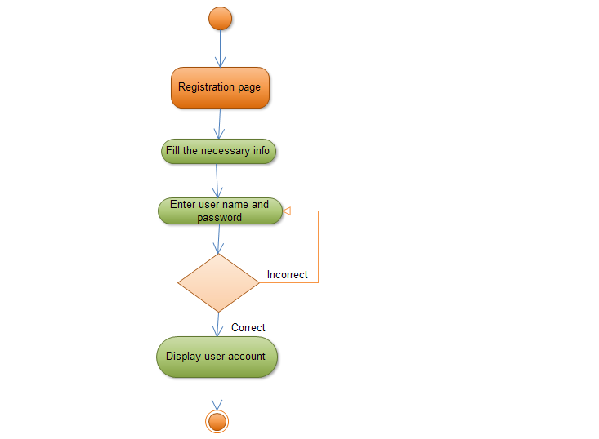

Figure 12 activity diagram for customer registration

* **Activity diagram for update customer info**

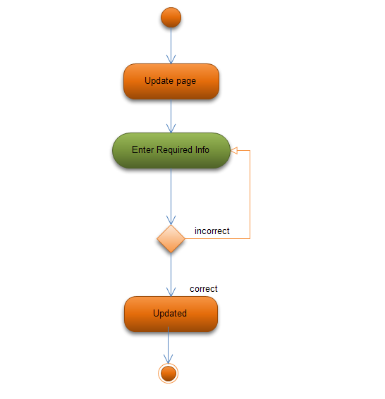

Figure 13 activity diagram for update customer info

* **Activity diagram for browse info**

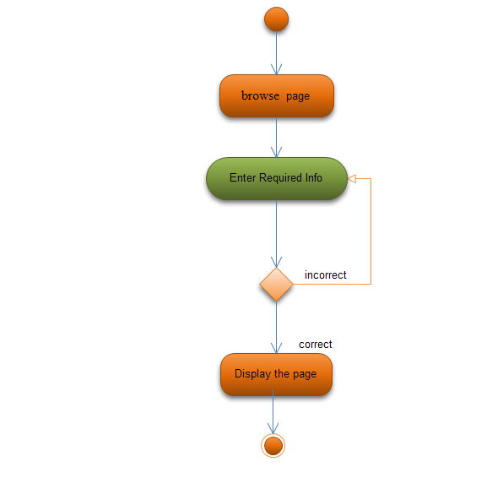

Figure 14 activity diagram for browse info

* **Activity diagram for view profile**

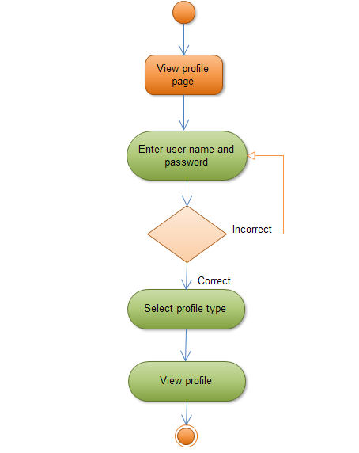

Figure view profile

* **Activity diagram for select reservation**

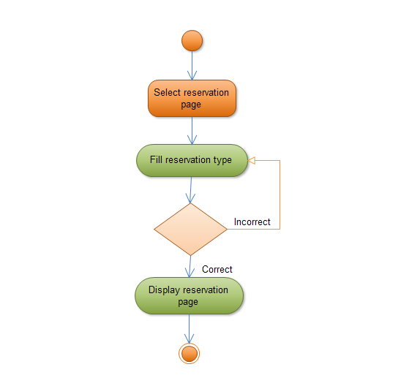

Figure 16 activity diagram for select reservation.

* **Activity diagram for delete reservation**

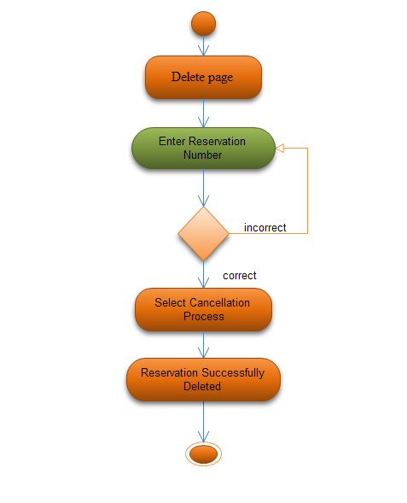

Figure 17 activity diagram for delete reservation

* **Activity diagram for generate report**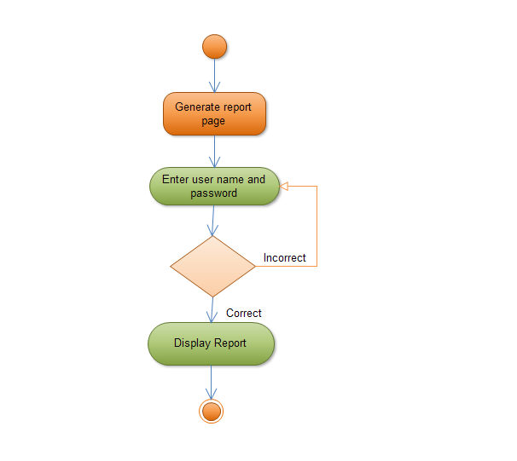

Figure activity diagram for generate report

## 3.2.5 Analysis Level Class Diagram (conceptual modeling)

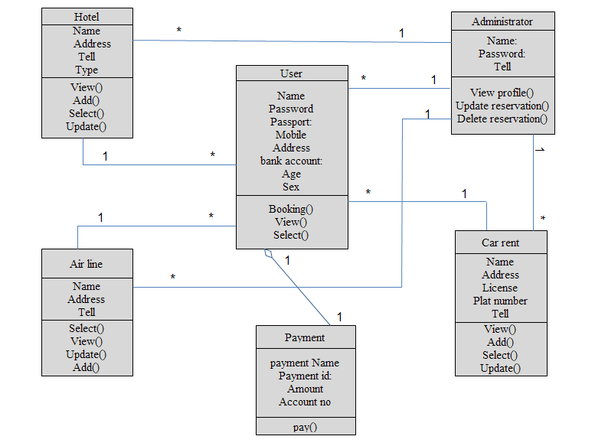

Figure 19 analysis level class diagram

## 3.2.6 User Interface Prototyping

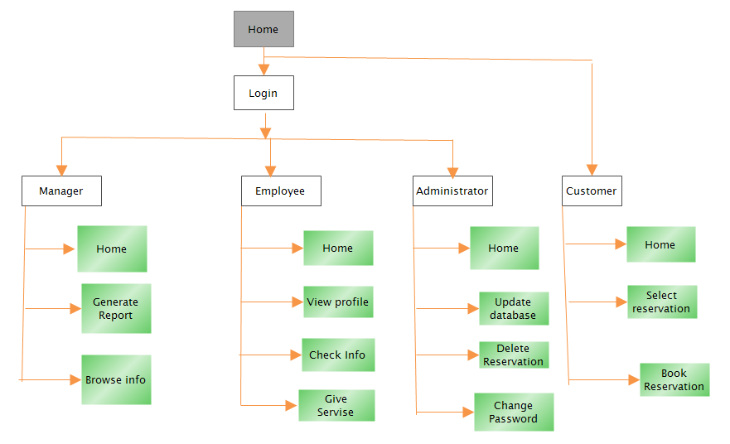

Figure user interface prototyping

## 3.2.7 Supplementary Specifications

Requirements applicable to the whole system or application such as security, conformance with standards, or availability are inappropriate to capture in use cases.

All system errors shall be logged. Fatal system errors shall result in an orderly shutdown of the system.

The system error messages shall include a text description of the error, the operating system error code (if applicable), and the module detecting the error condition, a data stamp, and a time stamp. All system errors shall be retained in the Error Log Database.

# Chapter 4

# 4.1 Introduction System Design

This project is designed in a manner that solves the problems of the organization by minimizing the work load that appears on the employees, because of the existing system is manual system. It provides more efficient, reliable and time saving system. In this project design the team will be

* How the project is designed
* What are tasks done under the whole project
* The different modules and their way of functioning are described here.

Generally, the project will be designed by addressing all of the above criteria of project design. It is designed to simplify functions of the manual system and it is capable of doing large amount of works in short period of time with more accuracy and reliability.

This design system is to involve converting the description of the proposed system into logical and then physical design specification. We expect one can understand our new system implementation because it gives full description about whole system. Also one can understand easily and enable to answer how the system developed and functioned in simplified manner.

The goal of system design according to the proposed project is to manage complexity by dividing the system into smaller, manageable pieces.

# 4.2 Class Type Architecture



Figure 21 Class type architecture

|  |  |
| --- | --- |
| **Layer** | **Description** |
| User interface | This layer wraps access to the logic of our system.  There are two categories of interface class – user interface (UI) classes that provide people access to our system and system interface (SI) classes that provide access to internal systems  to our system like database. The actors of this class are Administrator, Manager, Employee and Customer. |
| Domain/Business | This layer implements the concepts relevant to our business domain. The Administrator has the major role in business domain. |
| Process | The process layer implements business logic that involves collaborating with several domain classes or even other process classes. The actors are administrator and user. |
| Persistence | Persistence layers encapsulate the capability to store, retrieve, and delete objects/data permanently without revealing details of the underlying storage technology in the system. Administrator has to update and delete database. |
| System | System classes provide operating-system-specific functionality for our applications. User can access the system by using user name and password. |

Table class type architecture

# 4.3 Class Modeling

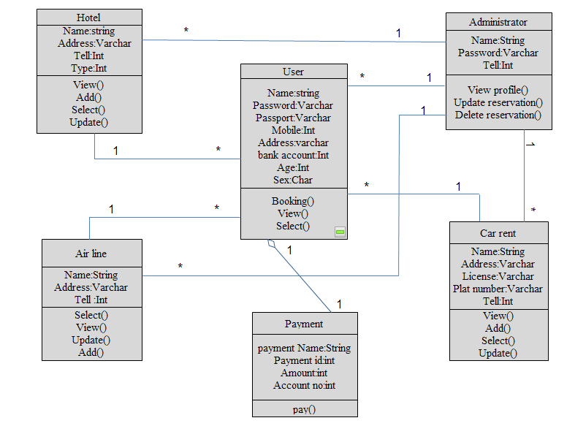

Figure class modeling

# 

# 4.4 State Chart Modeling

* ***State chart for login***

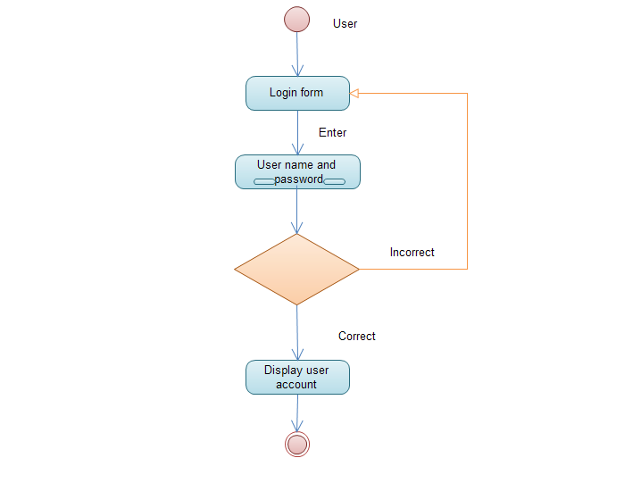

Figure 23 state chart for login

* **State Chart for Registration**

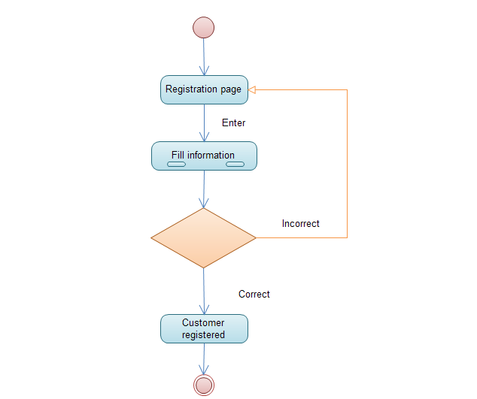

Figure state charts for registration

* **State Chart for Delete page**

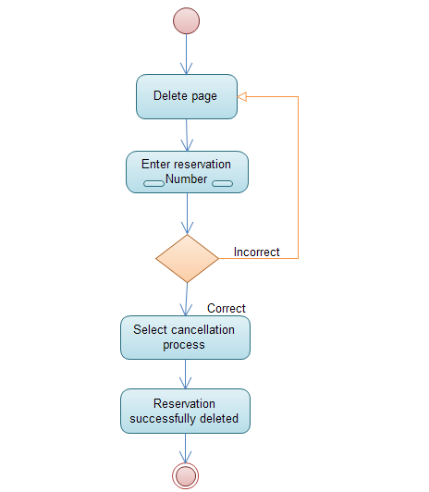

Figure state chart for delete page

* **State Chart for Update Page**

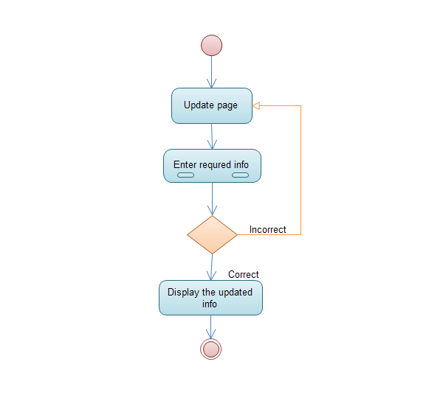

Figure 26 state chart for update page

* **State Chart for Browse info**

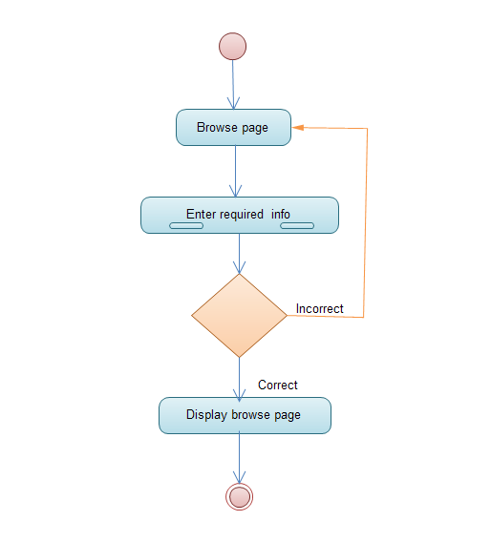

Figure Browse info

* **State Chart for select reservation**

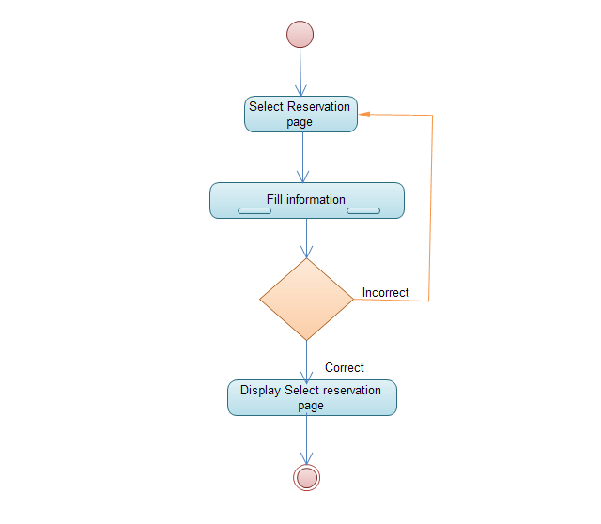

Figure select reservation

* **State Chart for Generate report**

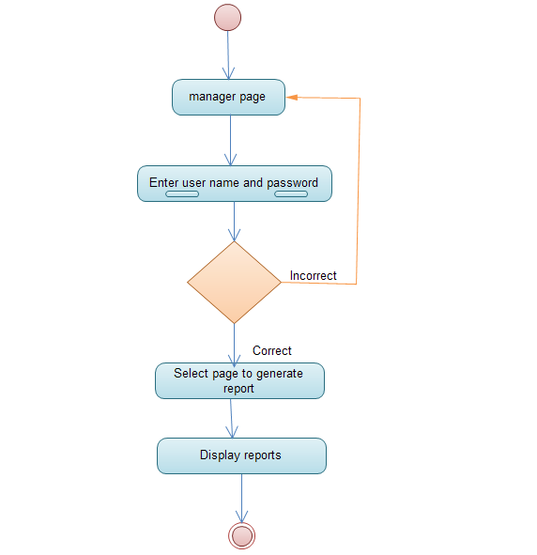

Figure Generate report

* **State Chart for View profile**

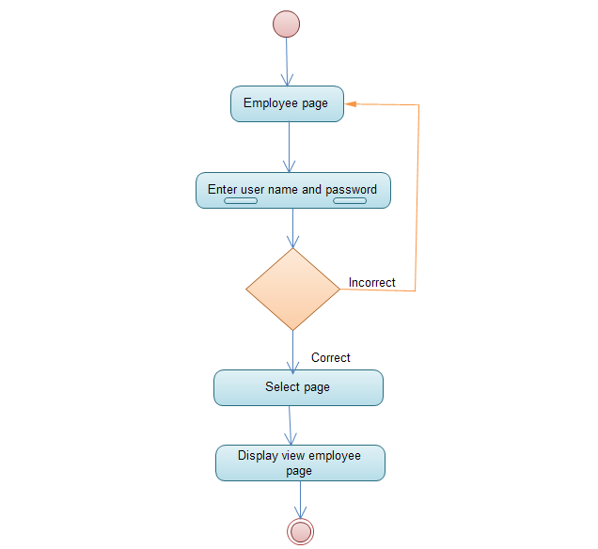

Figure View profile

# 4.5 Collaboration Modeling

* **Login**

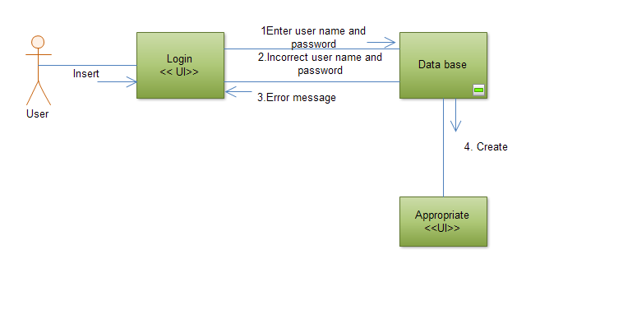

Figure 31 collaboration modeling for login

* **Registration** 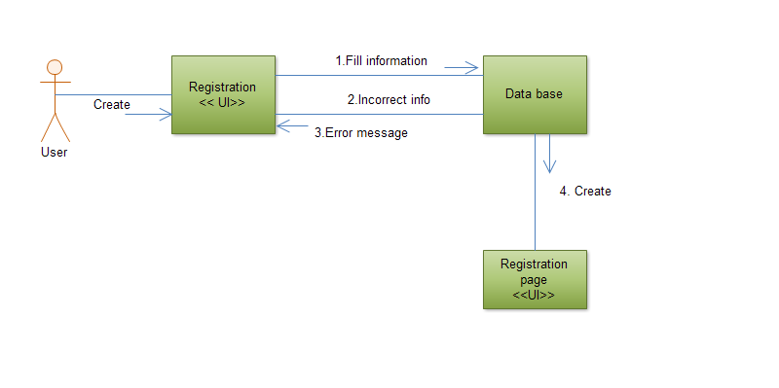

Figure 32 collaboration modeling for registration

**Delete Reservation**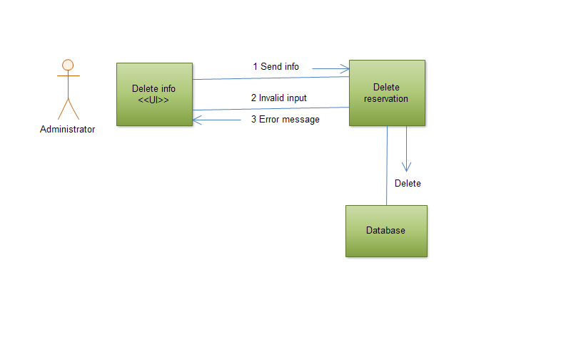

Figure Collaboration modeling for delete reservation

* Employee view profile page

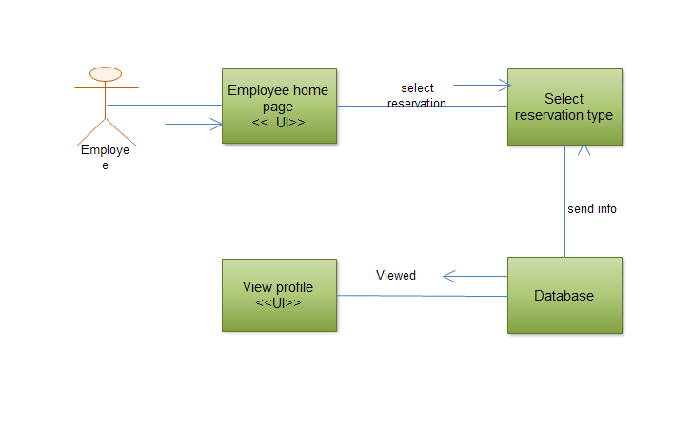

Figure view profile page

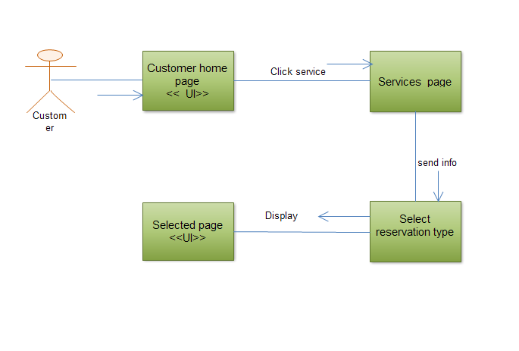

Figure Select reservation

* Browse information

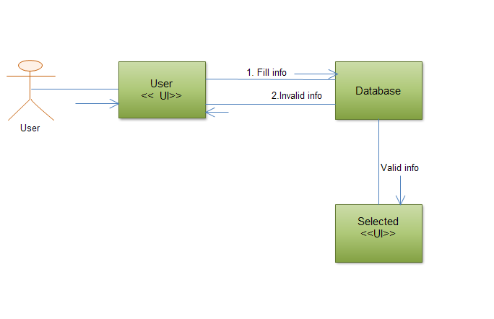

Figure Browse info

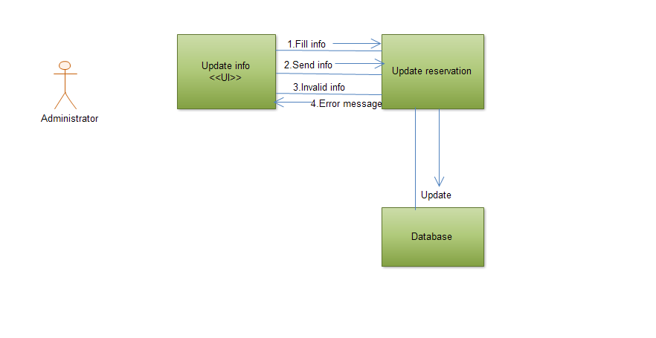

Figure update info

* Manager generate report

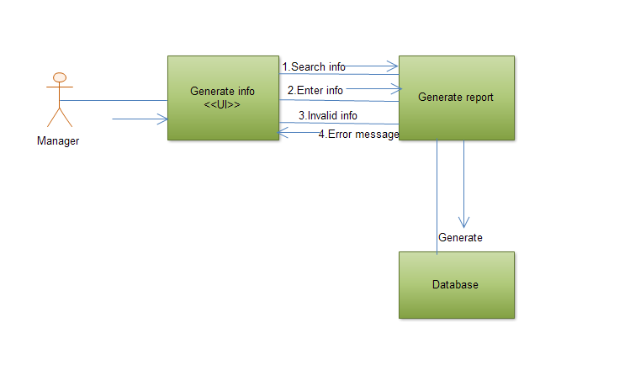

Figure generate report

# 4.6 Component Modeling

The component model illustrates the software components that will be used to build the system. We build it up from the class model and written from scratch for the new system. Components are high level aggregations of similar software pieces, and help us in providing a’ black box’ building block approach to software construction.

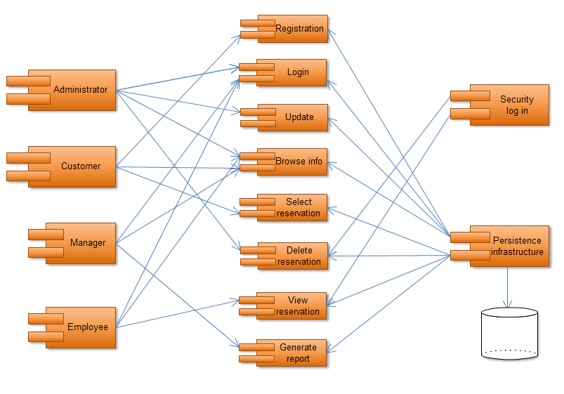

Figure component modeling

# 4.7 Deployment Modeling

UML deployment diagrams show the physical view of our system, bringing our software into the real world by showing how software gets assigned to hardware and how the pieces communicate. It is also used to show a collection of nodes and also dependencies of associations among them. The associations between nodes Represents a physical connection. The physical deployment model provides a detailed model of the way components will be deployed across the system infrastructure. It details network capabilities, server specifications, hardware requirements and other information related to deploying the proposed system.

# C:\Users\SARA\Desktop\ddd.png

Figure deployment modeling

# 4.8 Persistence Modeling

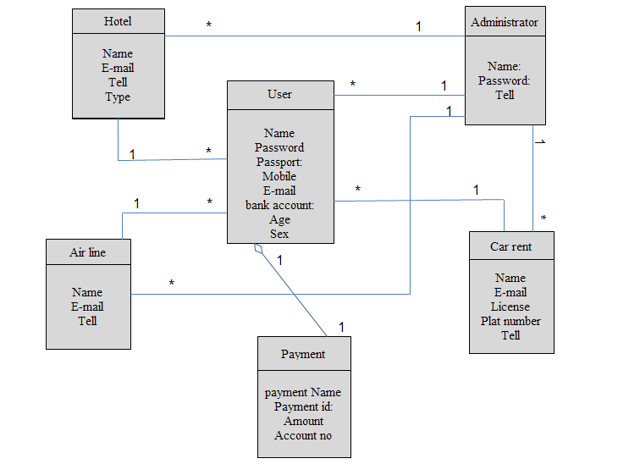

Figure persistence modeling

# 4.9 User Interface Design

* **Admin Login Page**

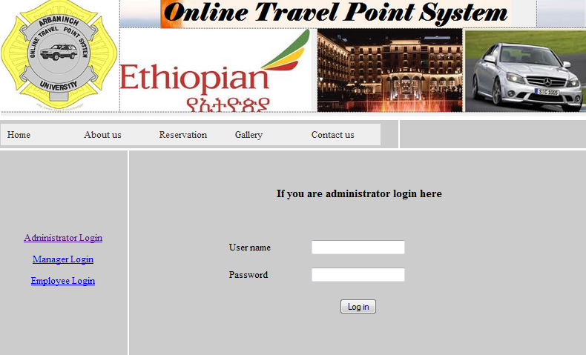

Figure Admin login

* **Users Hotel Reservation Page**

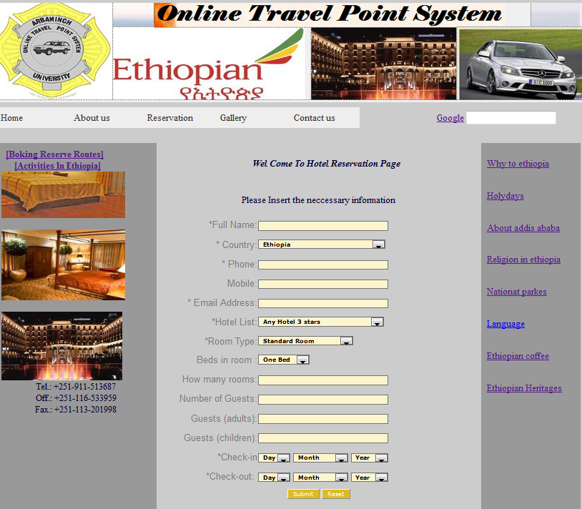

Figure Users hotel reservation page

# 

* **Users Airline Reservation Page**

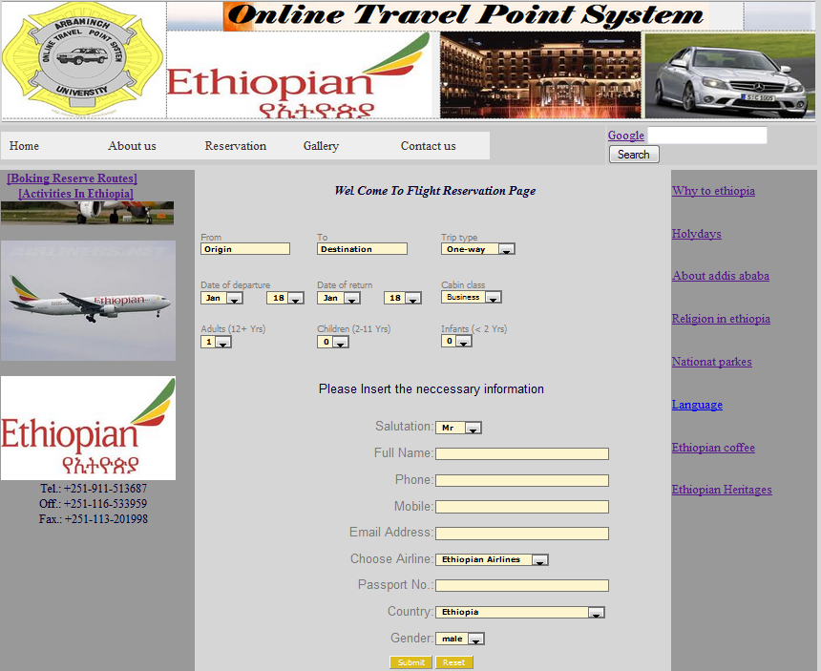

Figure users airline reservation page

* **Users Car Rental Reservation Page**

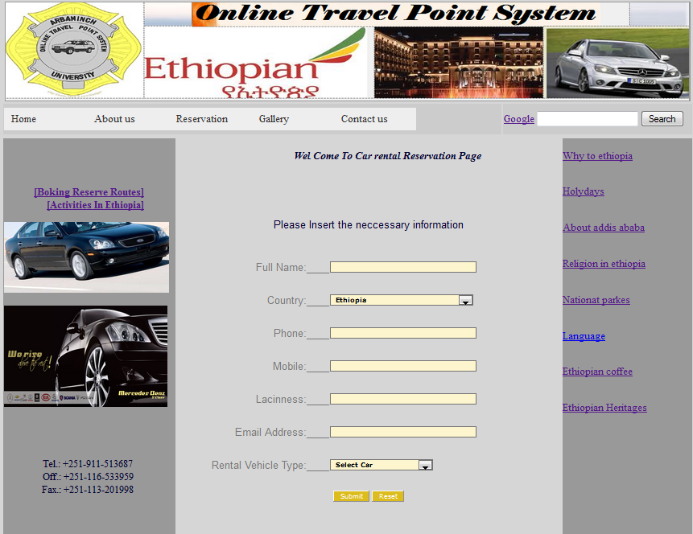

Figure Users car rental reservation page

# Chapter-5

## Implementation and testing

## 5.1 Introduction

During this phase physical design specification must be turned into working computer code, and provide help for current and future users and take care of the system. And then the code is tested until most of the errors have been detected and corrected. The purpose of this activity is to convert the final physical system specification into working model with reliable software and hardware.

## 5.2Testing

Testing is a process to show the correctness of the program and designed to analyze the logic used in the implementation of the System. In the case of our project we use unit testing method, this type of testing lead the user input and output to check whether login or registration is correct or not.

Table Testing

|  |  |  |
| --- | --- | --- |
| Test Case ID = Test Case 01 | | |
| Unit to Test = Registration of Users for car rentals | | |
| Assumptions = go to registration page | | |
| Full Name (invalid Full Name, Valid Full Name, empty)  Country (invalid country selection, valid country, select one of the country )  Phone number (invalid phone number, valid phone number, empty )  Mobile number (invalid Mobile number, valid Mobile number, empty )  Laciness (invalid Laciness, valid Laciness, empty )  Email Address (invalid Email Address, valid Email Address, empty)  Rental vehicle type (invalid vehicle type, valid vehicle type, select car) | | |
| Steps to be Executed | **Data** | Expected Results |
| Enter valid Full Name and Click register button | Full Name =xyz | “Correctelly entered Full Name ” |
| Enter invalid Full Name and Click register button | Full Name = 123 | “Please enter the correct Full Name”” |
| Empty Full Name and Click register button | Full Name =” ” | “Please enter Full Name” |
| Enter valid Phone number and Click register button | Phone number =0461544425 | “Correctelly entered Phone number ” |
| Enter invalid Phone number and Click register button | Phone number =0461544 | “Please enter the Correcte Phone number “ |
| Enter empty Phone number and Click register button | Phone number = “ ” | “ Entered Phone number” |
| Enter valid Mobile number and Click register button | Mobile number =0911544425 | “Correctelly entered Mobile number ” |
| Enter invalid Mobile number and Click register button | Mobile number =0461544 | “Please enter the Correcte Mobile number ” |
| Enter empty Mobile number and Click register button | Mobilenumber = | “ Entered Mobile number ” |
| Enter valid Lacinness and Click register button | Lacinness =wdre2323 | “Correctelly entered Lacinness” |
| Enter invalid Lacinness and Click register button | Lacinness =wdre2323 | “Please enter the Correcte Lacinness” |
| Enter empty Lacinness and Click register button | Lacinness = | “ Entered Lacinness” |
| Enter valid Email Address and Click register button | Email Address =tame@yahoo.com | “Correctelly entered Email Address ” |
| Enter invalid Email Address and Click register button | Email Address = tame.yahoo.com | “Please enter the Correcte Email Address ” |
| Enter empty Email Address and Click register button | Email Address = | “ Entered Email Address ” |
| Enter valid Rental vehicle type and Click register button | Rental vehicle type =toyota | “Correctelly entered Rental vehicle type” |
| Enter invalid Rental vehicle type and Click register button | Rental vehicletype = landrover | “Please enter the Correcte Rental vehicle type” |
| Enter empty Rental vehicle type and Click register button | Rental vehicle type = | “ Entered Rental vehicle type ” |

|  |  |  |
| --- | --- | --- |
| Test Case ID = Test Case 02 | | |
| Unit to Test = Registration of Users for flight reservation | | |
| Assumptions = go to registration page | | |
| From (invalid origin, Valid origin , empty)  To (invalid destination , valid destination, empty)  Trip type (invalid trip type, valid trip type, empty)  Date of departure (invalid departure date, valid departure date, empty)  Date of return (invalid date of return, valid date of return, empty )  Cabin class (invalid cabin class, valid cabin class, empty )  Adult (invalid input, valid input, empty )  Children (invalid input, valid input, empty )  Infant (invalid input, valid input, empty )  Salutation (invalid salutation input, valid salutation input, empty )  Full Name (invalid Full Name, valid Full Name, empty )  Phone number (invalid phone number, valid phone number, empty )  Mobile number (invalid Mobile number, valid Mobile number, empty )  Email (invalid Email Address, valid Email Address, empty)  Choose Airlines (invalid Airline, valid Airline, empty)  Passport Number (invalid Passport Number, valid Email Address, empty)  Country (invalid Country , valid Country, empty)  Gender (invalid Gender, valid Gender, empty) | | |
| Steps to be Executed | **Data** | Expected Results |
| Enter valid Full Name and Click register button | Full Name =ret | “Correctelly entered Full Name ” |
| Enter invalid Full Name and Click register button | Full Name = xyz | “Please enter the correct Full Name”” |
| Empty Full Name and Click register button | Full Name = “ ” | “Please enter Full Name” |
| Enter valid Country and Click register button | Country =Ethiopia | “Correctelly entered Country” |
| Enter invalid Country and Click register button | Country = Eth | “Please enter the correct Country”” |
| Empty Country and Click register button | Country = | “Please enter Full Name” |
| Enter valid Email Address and Click register button | Email Address =tame@yahoo.com | “Correctelly entered Email Address ” |
| Enter invalid Email Address and Click register button | Email Address = tame.yahoo.com | “Please enter the Correcte Email Address ” |
| Enter empty Email Address and Click register button | Email Address = | “ Entered Email Address ” |

|  |  |  |
| --- | --- | --- |
| Test Case ID = Test Case 03 | | |
| Unit to Test = Registration of Users for hotel reservation | | |
| Assumptions = go to log in page | | |
| Full Name (invalid Full Name, valid Full Name, empty )  Country (invalid Country , valid Country, empty)  Time Zone (invalid Time Zone , valid Time Zone, empty)  Phone number (invalid phone number, valid phone number, empty )  Mobile number (invalid Mobile number, valid Mobile number, empty )  Email (invalid Email Address, valid Email Address, empty)  Hotel List (invalid Hotel List, valid Hotel List, empty)  Room Type (invalid Room Type, valid Room Type, empty)  Bed In Room (invalid Bed In Room, valid Bed In Room, empty)  How Many Room (invalid Number of Room, valid Number of Room, empty)  Number of Guests (invalid Number of Guests, valid Number of Guests, empty)  Guests(Adults) (invalid Number of Adult Guests, valid Number of Adult Guests, empty)  Guests(Children) (invalid Number of Children Guests, valid Number of Children Guests, empty)  Check-In (invalid value of day, month and year, valid value of day, month and year,empty)  Check-Out (invalid value of day, month and year, valid value of day, month and year, empty | | |
| Steps to be Executed | **Data** | Expected Results |
| Enter valid Full Name and Click register button | Full Name =xyy | “Correctelly entered Full Name ” |
| Enter invalid Full Name and Click register button | Full Name = xy | “Please enter the correct Full Name”” |
| Empty Full Name and Click register button | Full Name = | “Please enter Full Name” |
| Enter valid Country and Click register button | Country =abc | “Correctelly entered Country” |
| Enter invalid Country and Click register button | Country = ab | “Please enter the correct Country”” |
| Empty Country and Click register button | Country = | “Please enter Full Name” |
| Enter valid Phone number and Click register button | Phone number =0461544425 | “Correctelly entered Phone number ” |
| Enter invalid Phone number and Click register button | Phone number =0461544 | “Please enter the Correcte Phone number |
| Enter empty Phone number and Click register button | Phone number = | “ Entered Phone number ” |

|  |  |  |
| --- | --- | --- |
| Test Case ID = Test Case 04 | | |
| Unit to Test = login for Admin | | |
| Assumptions = Logging in to Admin account | | |
| Test Data = Admin User Name (invalid Admin username, valid Admin username, empty)  Test Data = Admin Password (invalid Admin password, valid Admin password, empty) | | |
| Steps to be Executed | **Data** | Expected Results |
| Enter valid admin username and Click Login button. | AdminUsername=xyz | Should display an alert "Correctly entered Admin username!" |
| Enter valid admin password and Click Login button | AdminPassword=abc | Should display an alert “Correctly entered Admin Password!" |
| Enter invalid admin username and Click Login button. | AdminUsername=xy | Should display an alert "incorrect Admin username" |
| Enter invalid admin password and Click Login button | AdminPassword=abcd | Should display an alert “incorrect Admin Password" |
| Enter invalid admin username, valid admin password and Click Login button | Admin Username= xy  Password= abc | Should display an alert “please enter the correct Admin Username” |
| Enter valid username, invalid admin password and Click Login button | Admin Username= xyz  Admin Password= abcd | Should display an alert “please enter the correct Admin Password” |
| Enter invalid admin username, invalid admin password and Click Login button | Admin Username= xy  Admin Password= abcd | Should display an alert “please enter the correct Admin Username and Admin Password ” |
| Enter valid admin username, valid admin password and Click Login button | Username= xyz  Password= abc | Should display an alert “Successfully login to Admin account” |
| Test Case ID = Test Case 05 | | |
| Unit to Test = login for Employee | | |
| Assumptions = Logging in to Employee account | | |
| Test Data = Employee User Name (invalid Employee username, valid Employee username, empty)  Test Data = Employee Password (invalid Employee password, valid Employee password, empty) | | |
| Steps to be Executed | **Data** | Expected Results |
| Enter valid employee username and Click Login button. | Employeeusername=xyz | Should display an alert "Correctly entered Employee username!" |
| Enter valid employee password and Click Login button | Employeepassword=abc | Should display an alert “Correctly entered Employee Password!" |
| Enter invalid employee username and Click Login button. | Employeeusername=xy | Should display an alert "incorrect Employee username" |
| Enter invalid employee password and Click Login button | Employeepassword=abcd | Should display an alert “incorrect Employee Password" |
| Enter invalid employee username, valid employee password and Click Login button | Employee username= xy  Employee password= abc | Should display an alert “please enter the correct Employee Username” |
| Enter valid employee username, invalid employee password and Click Login button | Employee username= xyz  Employee password= abcd | Should display an alert “please enter the correct Employee Password” |
| Enter invalid employee username, invalid employee password and Click Login button | Employee username= xy  Employee password= abcd | Should display an alert “please enter the correct Employee Username and Employee Password ” |
| Enter valid employee username, valid employee password and Click Login button | Employee username= xyz  Employee password= abc | Should display an alert “Successfully login to Employee account” |

|  |  |  |
| --- | --- | --- |
| Test Case ID = Test Case 06 | | |
| Unit to Test = login for Manager | | |
| Assumptions = Logging in to Manager account | | |
| Test Data = Manager User Name (invalid Manager username, valid Manager username, empty)  Test Data = Manager Password (invalid Manager password, valid Manager password, empty) | | |
| Steps to be Executed | **Data** | Expected Results |
| Enter valid Manager username and Click Login button. | Managerusername=xyz | Should display an alert "Correctly entered Manager username!" |
| Enter valid Manager password and Click Login button | Manage**r** password=abc | Should display an alert “Correctly entered Manager Password!" |
| Enter invalid Manager username and Click Login button. | Managerusername=xy | Should display an alert "incorrect Manager username" |
| Enter invalid Manager password and Click Login button | Managerpassword=abcd | Should display an alert “incorrect Manager Password" |
| Enter invalid Manager username, valid Manager password and Click Login button | Manager username= xy  Manager password= abc | Should display an alert “please enter the correct Manager Username” |
| Enter valid Manager username, invalid Manager password and Click Login button | Manager username= xyz  Manager password= abcd | Should display an alert “please enter the correct Manager Password” |
| Enter invalid Manager username, invalid Manager password and Click Login button | Manager username= xy  Manager password= abcd | Should display an alert “please enter the correct Manager Username and Manager Password ” |
| Enter valid Manager username, valid Manager password and Click Login button | Manager username= xyz  Manager password= abc | Should display an alert “Successfully login to Manager account” |

## 5.3 Hardware and Software acquisitions

For the project implementation; the following Software and hardware are used.

**Hardware**

* Printer: For printing Documentation
* Server: for connection to the client computer(to host the system)
* Computers
* Network connection
* CD_ROM

**Software**

For the System implementation the following software’s are used.

* Apache server
* Dream weaver
* Notepad++
* Mysql database server

## 5.4 User manual preparation

Since the system is web based everything important for the user will be explained and implemented while giving short training when the system is deployed. Rather there is no need of preparing full user manual because it is only deployed (hosted) on a single machine that is server.

## 5.5 Training

During the deployment of the system, the project group members will give short time training for the system administrators explaining how the system works and in what way they can manage their system.

## 5.6 Installation

Since the project is a web based System, there is no need to install it on a particular machine rather it will be hosted on a server.

## 5.7 Start-up strategy

Once the system has been published, the user can start and access his/her authorized page by entering the correct user name and password with proper authentication and authorization processes but the customer can access our websites without user name password.

## 5.8 Coding

**Sample code for rental profile**

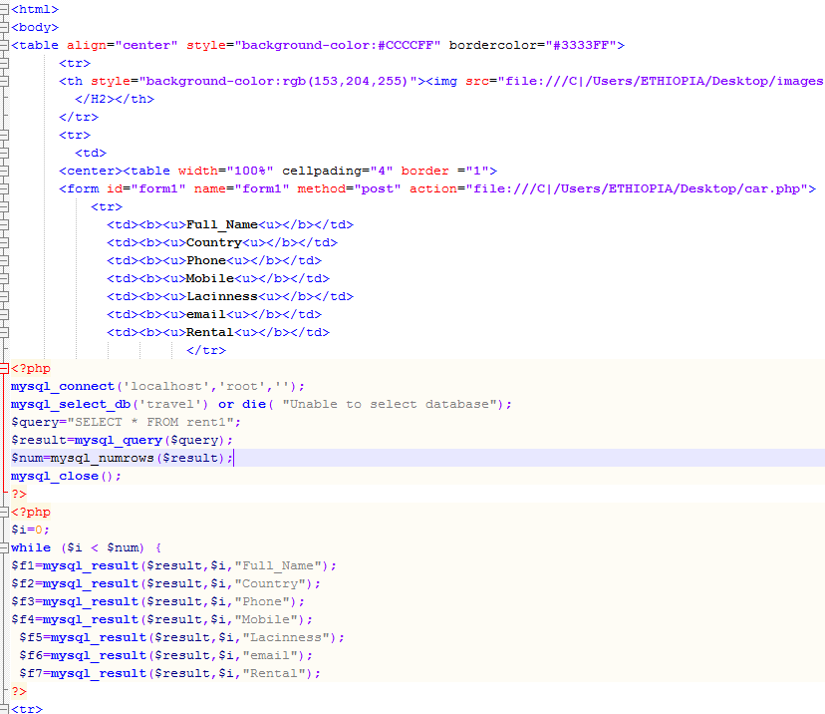

**Update sample code**

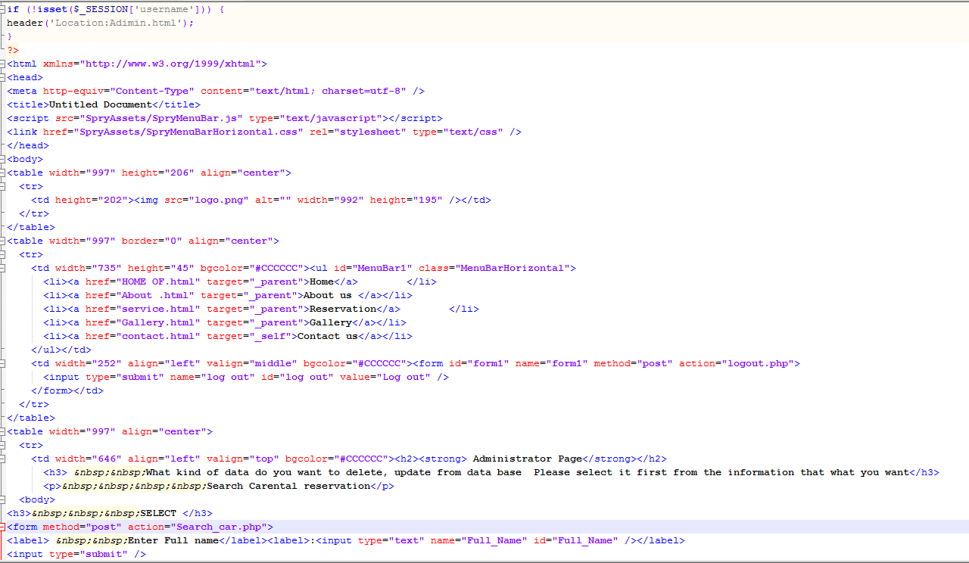

**View air_ profile sample**

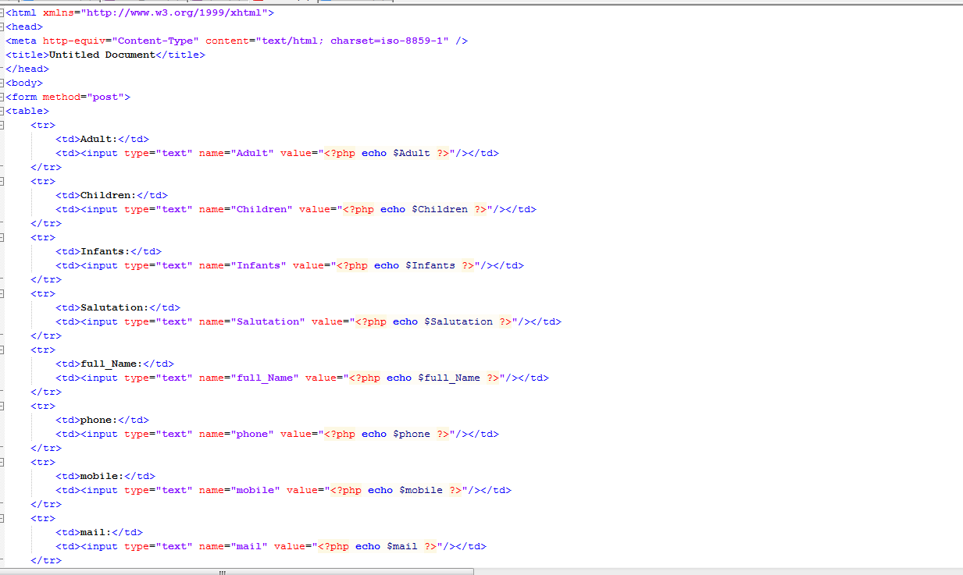

**Delete car rental reservation sample**

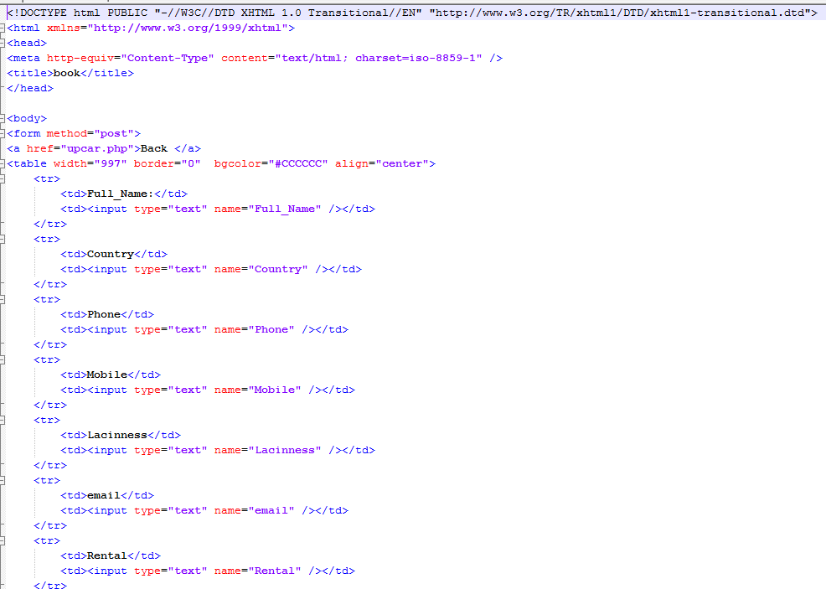

**Car rental registration form sample**

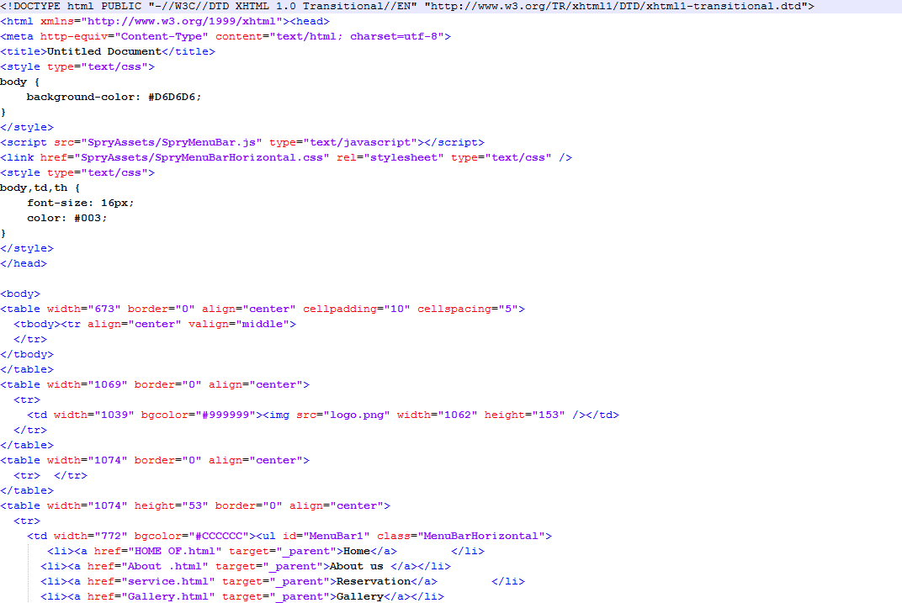

**Delete hotel sample** 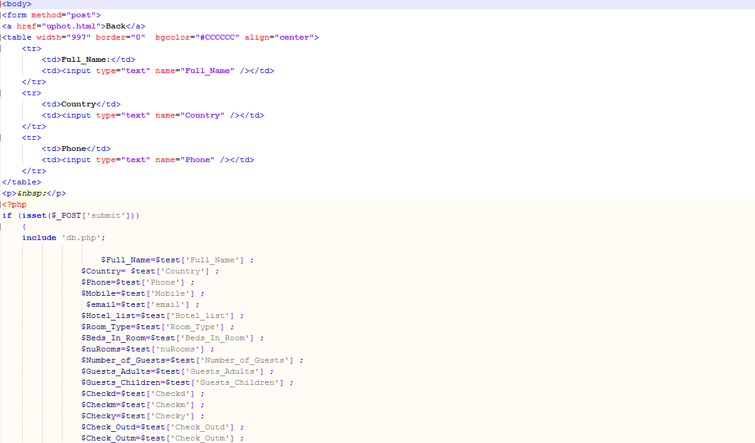

# Chapter Six

## Conclusions and Recommendations

## 6.1 Conclusions

Online travel point system provides many services such as Airline Reservation System (ARS), Hotel Reservation System (HRS) and Car Rental System (CRS) and this project is designed in order to meet the requirements of customer’s.Also the system combines the three systems which are airline, car rental and hotel reservation systems.

Our project covers various features like online registration of the users, modifying the details of the website by the management staff or administrator of the website, by adding, deleting or modifying the customer details, flights or packages information, In developing this project all group members contributed their full capability with maximum interest and all group members get ways toward developing this project.

Finally our project solves the problem that occurred in the existing system**.**

## 6.2 Recommendations

According to scope of our project the team develops web application .Because of the time

Constraint we may have some limitations which should be taken in considerations, but in the future the team believes that this system can be fully operational by having some functionalities that are not included in the proposed system like paying online for the service we gate .

During the development of the project the group members faced many challenges However by the cooperation of all the group members and an advisors the team is now able to reach to the final result through this way we try to construct the road and hence this project has a big role in Ethiopia.

Finally the team would recommend that further work should done on the system in order to make the system perform better for interested organizations who would like to use online travel point system in Ethiopia.

## References

* Some paper material from tourist hotel and Ethiopian airline Arba Minch branch
* Selameta magazine.
* BRC Budget tour and travel
* www.poshtravelethiopia.com
* Nech sar national park
* Passion Ethiopia Tours (PET)
* Ezana Arba Minch hotel
* For Travel to Ethiopia, Adventure, Guide and Information center
* Ethiopian tourism commission
* Fana Travel & Tours
* Ethio-Der Tour and Travel
* Eastern Travel & Tours Agency
* The Object Primer Second Edition book

## Internet Site reference:

* [www.tourismethiopia.com](http://www.tourismethiopia.com)
* [www.ethiopian](http://www.ethiopian) airline.com
* [www.adikatour](http://www.adikatour)&travel.com
* [www.yamatoursethiopia.com](http://www.yamatoursethiopia.com)
* [www.elmitourethiopia.com](http://www.elmitourethiopia.com)
* [www.ethiopiantourism.com](http://www.ethiopiantourism.com)